

An Electronic Voting System

A proposal for the ICOM 5017 Course
Section 031
Javier Torres Santiago ID# 802-03-8529
Sylvia Rodríguez Rodríguez ID# 802-03-7033
Angel Vega Cortés ID# 844-02-9732
Laura Cruz Rodríguez ID# 802-03-1797
Contents
1. Executive Summary 6
2. Abstract 7
3. Overview 8
3.1. Introduction 8
3.2. Problem statement 8
3.3. The Project 8
3.3.1. The Voting Process 8
3.3.2. Legal implications 10
3.3.3. Privacy issues 12
3.3.4. Current issues 12
3.3.5. Market Study 13
3.4. Proposed Solution 17
4. Project Overview 18
4.1. Block Diagrams 18
4.1.1. Raven Design 18
4.1.2. Sparrow Design 19
4.2. Risk Analysis 20
4.3. Budget 21
4.3.1. Raven 21
4.3.1.1. Personnel 21
4.3.1.2. Hardware 22
4.3.1.3. Budget Results 22
4.3.2. Sparrow 23
4.3.2.1. Personnel 23
4.3.2.2. Hardware 23
4.3.2.3. Budget Results 24
4.4. Function Points 24
4.4.1. Raven 25
4.4.2. Sparrow 26
4.5. Task Division 27
4.5.1. Proposal Assignments 27
4.6. Schedule 28
4.7. Work Breakdown Structure 29
4.8. Project Assessment and Evaluation 30
5. Project Design 31
5.1. Overview 31
5.2. Chosen Software Design Model 31
5.3. Chosen Programming Design Model 31
5.4. Model Design Decisions 32
5.5. Design Goals 33
5.5.1. Proposal 33
5.5.2. Oral Exams 33
5.5.3. Final Prototype 33
5.5.4. Required Project Activities 34
5.5.5. Deliverables 34
6. Raven Design 35
6.1. Voting Module 35
6.1.1. Overview 35
6.1.2. Requirements Analysis 35
6.1.2.1. Hardware requirements 35
6.1.2.2. User Requirements 36
6.1.2.3. Restrictions 36
6.1.2.4. Database Requirements 36
6.1.3. Security Requirements 39
6.1.4. Software Trust Issues 39
6.1.5. Ballot Design 40
6.1.6. Design Decisions 42
6.1.6.1. Decision Background 42
6.1.6.2. Microprocessor Design Decisions 43
6.1.6.3. LCD Screen Design Decisions 45
6.1.6.4. Printer Decisions 46
6.1.6.5. Touch Screen Decisions 47
6.1.7. Program Design 47
6.1.7.1. Raven Flowchart 47
6.1.7.2. Raven Interface design 48
6.1.7.3. Program Design 55
6.1.7.4. Software Design Considerations 55
6.1.8. Hardware Design Considerations 56
6.2. Tallying Module 56
6.2.1. Overview 56
6.2.2. Requirements Analysis 57
6.2.2.1. Interface Requirements 57
6.2.2.2. Input and Output Requirements 57
6.2.2.3. Functionality Requirements 57
6.2.2.4. Restrictions 57
6.2.3. Design Decisions 57
6.2.4. Program Design 61
6.2.4.1. Program Screens 61
7. Sparrow 64
7.1.1. Overview 64
7.1.2. Database Design 64
7.1.3. Design Decisions 64
7.1.3.1. Design Overview 64
7.1.3.2. LCD Design Decisions 65
7.1.3.3. Printer Decisions 66
7.1.3.4. Microprocessors Decisions 66
7.1.3.5. Keypad Navigation 67
7.1.4. System Design 67
7.1.5. Program Design 68
7.1.5.1. Program Design Screens 68
7.1.5.2. Sparrow Flowchart 71
7.1.5.3. Sparrow Interface Design 72
7.1.5.4. Software Design Considerations 78
7.1.6. Hardware Design 78
8. Future Work 80
8.1. Overview 80
8.2. Fingerprint Scanning 80
8.3. Accessible electronic voting 81
9. Glossary 82
10. Team 83
10.1. Javier Torres Santiago 83
10.2. Sylvia Rodríguez Rodríguez 83
10.3. Angel Vega Cortés 83
10.4. Laura Cruz Rodríguez 84
10.5. Team Training 84
11. References 85
12. Appendix 88
12.1. Gantt Chart 88

Executive Summary
The purpose of this proposal is to implement an electronic voting system as an alternative for Puerto Rico’s current voting system. Puerto Rico’s current voting system uses the traditional paper ballot and manual tallying by employees. Even though this system has been helpful for many years, there are disadvantages. The two main disadvantages we are focusing on are: the time consuming process of managing and tallying paper ballots, and the possibility of human error in the tallying process.
Our proposed system will address these disadvantages by electronically registering the voter, allowing the voter to cast his/her vote, printing a voter verifiable paper audit trail, and finally tallying the total amount of votes. The system will be divided into two categories: hardware and software. The hardware aspect, involves the electronic device in which the voters will be interacting with directly. The software aspect will be the management tool the employees will be using in the management and tallying of the paper ballots.
Our preliminary prototype will be completed by November 26th, 2008 and the user manual on November 28th, 2008. This prototype will provide the basic functionality of an electronic voting system.
We have researched the current market for electronic voting systems and evaluated our current competitors’ designs. We believe that our design incorporates the features that are most important and crucial for the acceptance of the general public of Puerto Rico. For example, an easy-to-use touch screen interface in the electronic device.
As of today, no attempt has been made to implement such a system in Puerto Rico. Therefore, the profitability of the project will be substantial since we will be the pioneers in the market of electronic voting systems in Puerto Rico.

Abstract
Puerto Rico’s current voting system consists of the traditional paper ballot. Even though it has been in use for many years now, there are disadvantages. The organization required by employees to manage and tally the paper ballots becomes time consuming and there is the possibility of human error in the tallying process.
In order to solve these problems we propose the implementation of an electronic voting system. The system will register voters upon arrival; allow them to cast their vote, print a confirmation receipt for verification, and finally tally the total votes.

Overview

Introduction
When election season comes around, we are constantly reminded: “Every vote counts!”. It is an important right for every citizen, but what happens when our current voting system does not take into account ‘every single vote’. Human error is probable in these systems in the form of bypassing, misreading, or miscounting a vote. Today’s citizens are aware of this factor; some even might be discouraged not to vote. What if an alternative could be implemented to provide a more efficient, faster, and reliable voting system? It would reduce the human error factor and increase voter’s participation in the process.
The alternative is an electronic voting system and this technology has already been implemented in several parts of the world, some more successful than others [1] . We propose to implement an electronic voting system for the Commonwealth of Puerto Rico.

Problem statement
The problem consists of the inefficiency in Puerto Rico’s traditional voting system. This is due by two factors: managing and tallying paper ballots and the probability of human error in the tallying process. With an electronic voting system the votes can be managed and tallied electronically, reducing the time involved in this process. The probability of human error is reduced since the system will manage directly the ballots, it will also leave a voter verified paper audit trail of votes in the case of a re-count.

The Project

The Voting Process
In order to be eligible to cast your vote, a person must comply with the following:
- Be an active elector.
- Appear on the Voting Lists.
- Possess and display your voting card and visit your corresponding Voting Center between 8:00a.m. and 3:00p.m.
At the Voting Center, the person will be asked to sign in and will receive three distinct ballots. The first ballot will be the State ballot (white) in which you can elect the Governor and Resident Commissioner. The second ballot will be the Legislative ballot (light brown) in which you can elect the Senate and Chamber of Representatives. The third and final ballot will be the Municipal ballot (yellow) in which you can elect the Major and Municipal Assembly. The amount of candidates you are able to vote for, varies according to the type of ballot.
Starting with the State ballot (white), the person has the right to vote for one (1) candidate for Governor and one (1) candidate for Resident Commissioner. Continuing with the Legislative ballot (light brown), the person has the right to vote for: one (1) candidate for District Representative, a maximum of two (2) candidates for District Senators, one (1) candidate for Representative at large, and one (1) candidate for Senator at large. Finally with the Municipal ballot (yellow), the person has the right to vote for: one (1) candidate for Major and the maximum of Municipal Legislators that correspond to your municipality.
In Puerto Rico, there are basically three ways to cast your vote: integral, mixed, and by candidate. In order to cast an integral vote, on the State ballot (white), mark (X) only once (1) in the space provided below the persons’ preferred party’s banner. This mark alone will count for both the Governor and Resident Commissioner. On the Legislative ballot (light brown), mark (X) only once (1) in the space provided below your preferred party’s banner. This mark alone will count for one (1) District Representative, two (2) District Senators, one (1) Representative at large and one (1) Senator at large who are in first place and will be the only ones who accumulate integral vote in each precinct. Lastly, on the Municipal ballot (yellow), mark (X) only once (1) in the space provided below your preferred party’s banner. This mark alone will count for both Major and Municipal Legislators that are eligible by law.
In order to cast a mixed vote, if the elector has already voted under a party’s banner, but still has preferences for one or more candidates from other parties, you are able to mark (X) on the left side of those candidates corresponding names. You can also vote for someone who is not listed as a candidate, by writing his/her name under the Direct Nomination column.
In order to cast a vote by candidate, the elector exclusively wants to vote for one or more candidates and is not interested in voting under a party’s banner, you are able to mark (X) of the left side of your preferred candidates. You can also vote for someone who is not listed as a candidate, by writing his/her name under the Direct Nomination column.
If the voter were to make a mistake and ruin his/her ballot. He/she will return the ruined ballot or ballots to a public official at the school, who will then in return supply the person with the same type of ballot or ballots. Under no circumstances, will more than two (2) ballots of the same type be handed out to the same person.
An elector’s vote could be cancelled or considered void if one of the following were to occur: if the person voted for more than one (1) party’s banner, if you were to write names or initials that don’t correspond to the candidates, and if you would tear apart a party’s banner, write obscenities, or make any additional markings that are not necessary for casting you vote [2].
Finally, we conclude this section with an interesting fact. In the 2004 elections, the voter participation was registered at 81.7%, making Puerto Rico one of the highest records of voter participation in election processes in the world [3].

Legal implications
To guarantee a free and fair election that reflects the will of the people, the Puerto Rico Electoral Law declares the following, among other, rights and prerogatives of the voter [4].

- The Commonwealth’s election bodies will work within a framework of strict fairness, integrity, and justice.

- The guarantee of an equal, free, direct, and secret vote.

- The right to get one replacement ballot for each contested race if the voter makes a mistake.

- Any voter physically unable to mark his/her ballot (due to blindness, inability to use both hands, or other physical impediment) may choose a person, who may or may not be a polling place official, who will, with due safeguards to the secrecy of the vote, assist the voter in parking the ballot as instructed by the voter.

- The right to vote provisionally in the “manually added” polling place, if a voter shows up and his name is not on the voter registration list. A voter will be notified if his vote is not counted, and the reason it was not counted, in such circumstances. Additionally a voter has the right to oppose any rejection of his/her ballot for reasons allowed by law.

- An individual citizen’s voting right takes precedent over the rights of political parties and groups.

- A voter’s registration may not be rejected, cancelled, invalidated or voided, nor may a qualified voter’s right to vote be denied, except in strict compliance with the electoral law or by order of a court.

- A voter may not be arrested on his way to register or vote, during registration or voting, or returning from registering or voting, except if he/she commits a felony, violates the electoral law or disturbs the peace.

In the United States, each state has its own laws and regulations regarding elections, although every state must meet certain requirements.

- The Voting Rights Act of 1965 establishes provisions of voting assistance to voters who are blind, illiterate or disabled [13].

- The Uniformed and Overseas Citizen Absentee Voting Act of 1986 (UOCAVA) requires that states allow certain groups of citizens to register and vote absentee in elections for federal offices [29].

- The Voter Confidence and Increased Accessibility Act of 2003 (VCIAA) requires a voter-verified permanent record of hardcopy in electronic voting systems [30].

- The Help America Vote Act of 2002 (HAVA) establishes a program to provide funds to States to replace punch card voting systems, to establish the Election Assistance Commission to assist in the administration of Federal elections and to otherwise provide assistance with the administration of certain Federal election laws and programs, to establish minimum election administration standards for States and units of local government with responsibility for the administration of Federal elections, and for other purposes [31].

Privacy issues
There is currently one main privacy issue regarding the VVPT (Voter Verified Paper Audit Trail) [5]. This could be seen as a double edged sword, on one side both the machine’s memory device, and a physical paper trail record each ballot. Then each voter could then compare the paper trail to the results screen on the DRE monitor to verify his/her vote was counted properly. Consequently, a voter’s anonymity might be at risk. A voter’s ballot cannot be linked back to a specific voter without compromising confidentiality. Paper-based ballots or a DRE system that generates a paper trail create a physical record of each voter’s choices.

Current issues
We found two current issues that are directly related with electronic voting systems and the voting process in Puerto Rico: the IEEE 1583 standard and the language used for the ballots [6]. The first issue consists of the IEEE developing a standard for the evaluation of voting equipment which is called IEEE 1583. It is a performance standard, which means it will not specify how a voting machine should be designed or manufactured. Instead, the standard outlines what a voting machine must do. Once the IEEE 1583 is accepted by the U.S. Election Assistance Commission (EAC), it will be the law of the land, and all voting machines used in federal elections must comply with the standard. The standard is still pending and will not be ready for the 2008 election, but the committee hopes that by the next election the standard will be ready.
The second issue is related to a recent lawsuit filed by two mainland-born Americans living on the island who argued a Spanish-only ballot discriminates against the 14% of the nearly 4 million inhabitants in Puerto Rico whose first language is English. The federal judge Jose A. Fusté ordered election officials to add an English translation to Spanish-only ballots for November elections [7], [8].

Market Study
In the United States elections in November 2006 only six types of voting equipment was utilized [9]:
- Punch card
- Lever
- Paper
- Optical
- Electronic
- Mixed Systems

Our proposal falls in the category of electronic voting systems, also known as DRE (Direct Recording Electronic) systems. In these previous elections approximately 36.6% of the counties in the U.S. used electronic voting equipment, being the second most used in the U.S. [10]. (See Figure 1)
Due to the HAVA act, the implementation of electronic voting systems has increased in the U.S. since the year 2000.
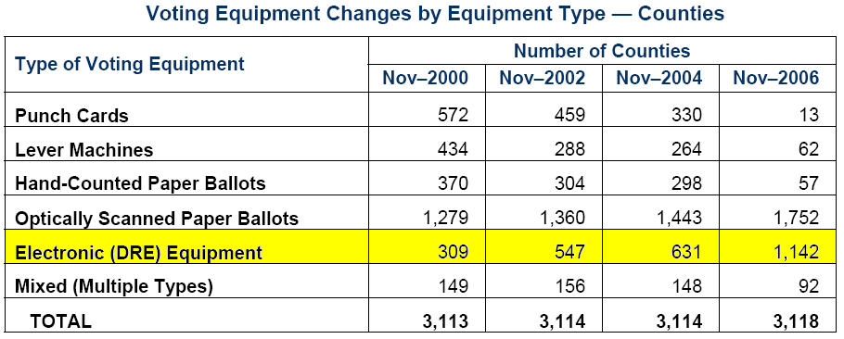
Voting Equipment Changes . Taken with permission from Election Data Services, Inc. [11]
Table 1
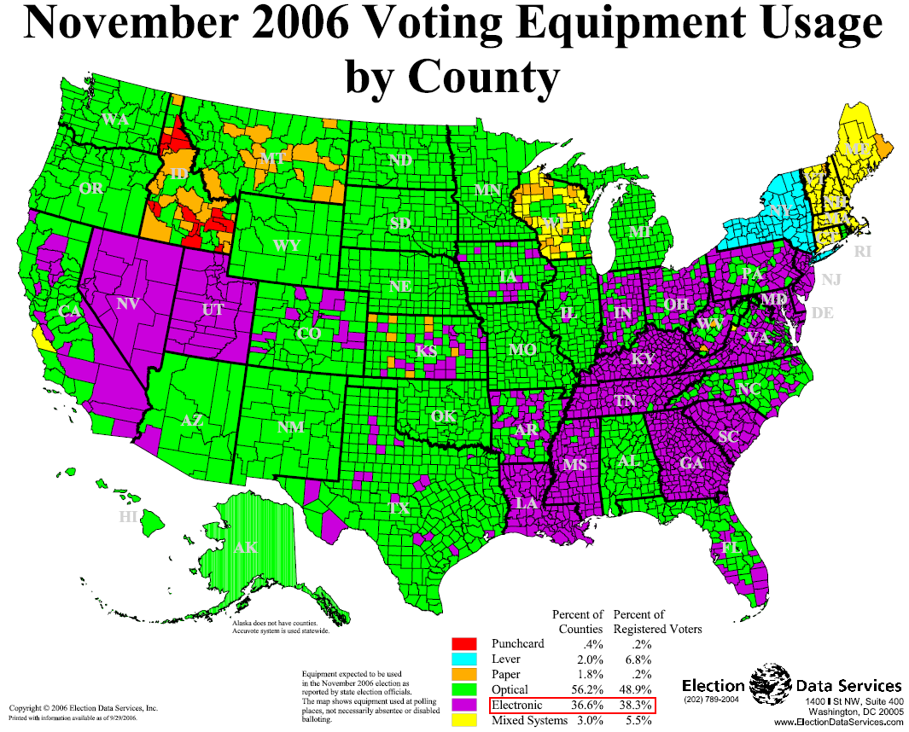
Voting Equipment Usage in the United States. Taken with permission from Election Data Services, Inc. [12]
Figure 1
It is evident that in future elections the use of electronic voting systems will increase, thus providing us an opportunity to expose our product to the market. Focusing back on Puerto Rico, a potential customer would be the “Comisión Estatal de Elecciones”. As of today, no electronic voting system has been implemented in the Puerto Rico elections. Therefore, we would compare our product with similar systems outside of Puerto Rico.
Given that there are more than 16 DRE systems used in the 2006 U.S. elections [9]. We will only consider three out of the four modules that accounted for 64% of all DRE Systems used in that year, being that one manufacturer may have withdrawn out of the DRE market [5]. We will also take into consideration the DRE system produced by Software Improvements which went through a trial run in a state election in 2001 in Australia and proved to be quite a success [1].

- iVotronic (produced by ES&S)
- AVC Advantage (produced by Sequoia Voting Systems)
- ELECTronic 1242 a.k.a “Shouptronic 1242” (produced by Danaher)
- eVACS “Electronic Voting and Counting System” (produced by Software Improvements)
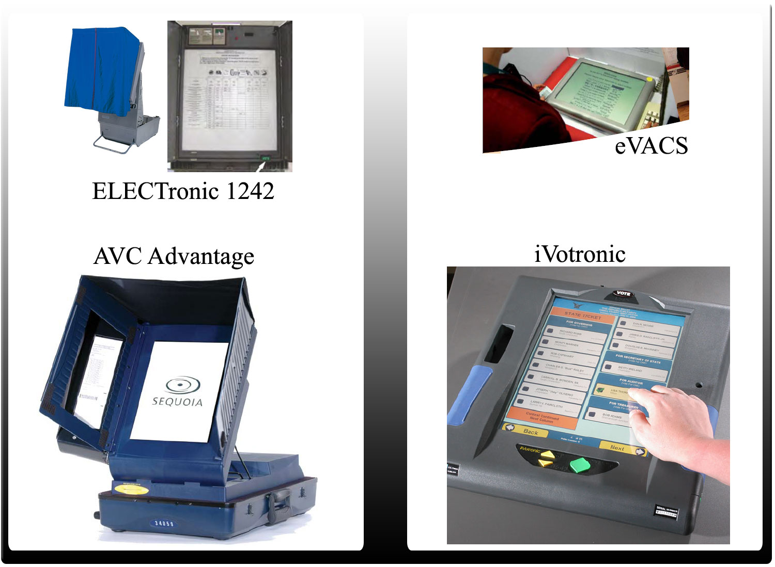
Electronic voting systems
Figure 2

Though the size, shape, weight and certain features vary among the four products, they all provide the same basic functionality for voting, which are: provide an easy-to-use interface, a touch screen LCD, voter registration, eliminate over-voting, minimize under-voting, be made accessible to handicapped citizens, prompt the user to confirm his/her vote before submitting, tallying votes, and being secure medium throughout the whole process [14], [15], [16], [17].
Our complete design will consist of more or less the same features provided by the previous products. This will be covered in detail in the following section.

Proposed Solution
Before even entering the design process, we took into account the success of Australia’s electronic voting system. The team analyzed how we would implement the system in Puerto Rico, taking into consideration all legal aspects, culture trends, and usability for all age groups. As for the human interaction with the device, a touch screen LCD and an easy-to-use interface was a must in our design. It would not be such a dramatic change for voters and the learning curve would not be so steep. Preventing voters from over-voting, minimizing under-voting, and prompting the voter for a confirmation before submitting will build credibility with critics of DREs, demonstrating that our system was designed with the voter in mind. Another way we plan to ease the transition to a DRE system would be going public with our source code.
What better way to gain acceptance from the citizens of Puerto Rico, than permitting them to see our source code first hand. It proved to be amazing result in Australia, and we believe that the people of Puerto Rico would also appreciate and feel more comfortable know what’s going on behind the scenes. Finally, we will implement the VVPT (Voter Verified Paper Audit Trail) in order for the voter to physically hand in a record of his/her vote, instead of just voting only electronically.

Project Overview
The following section includes the different factors to take into consideration for this project.

Block Diagrams

Raven Design
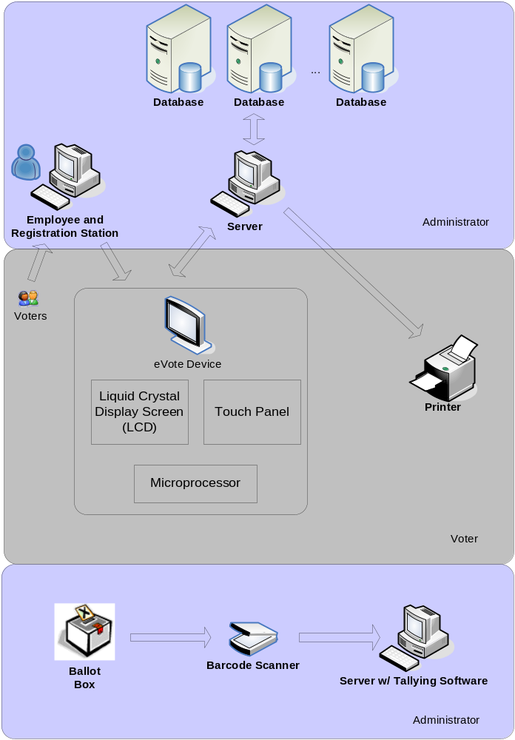
Raven System block diagram
Figure 3
The voters will register at the Registration Station once they arrive to place they are assigned for voting. An employee will direct the voter to a station where the voter will find an eVote Device as well as a printer. The eVote device will be connected to a server that is connected to the data base for storing the voter selection. Once the voter is finished, he will receive a receipt ballot. The user will deposit the receipt in the ballot box. If there is a case that requires recounting of the votes, an authorized team will scan each of the barcodes on each of the ballots and the server with the Tallying Software will count and give the results of the votes once all the ballots are scanned.

Sparrow Design
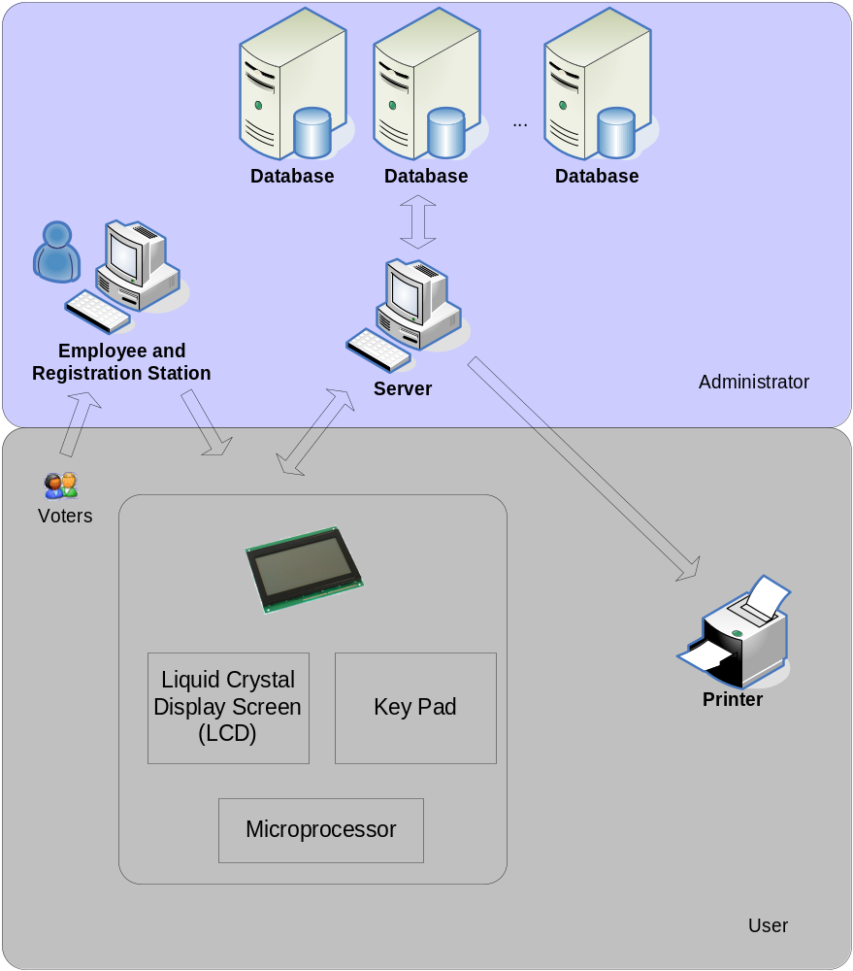
Sparrow System Block Diagram
Figure 4

The voters will register at the Registration Station once they arrive to place they are assigned for voting. An employee will direct the voter to a station where the voter will find an eVote Device as well as a printer. The eVote device will be connected to a server that is connected to the data base for storing the voter selection. Once the voter is done, he will receive a receipt ballot.

Risk Analysis
There are four risks identified which may impact the development and schedule of the project. Each of the risk was analyzed to determine the probability of materialization as well as a mitigation and response action.
- The first risk identified is to have an LCD (Liquid Crystal Display) broken or damaged. The probability for this risk is medium, since none of the team members has work with LCDs before. Since the LCD is an important hardware component in out design if the risk materializes there will be a delay on the project. As a mitigation action we have a spare LCD. As a response action the team will replace the damaged LCD with the spare part.

- The second risk identified is a natural disaster such as a hurricane. Since we are on hurricane’s season the probability for this risk to materialize is medium. In the case the risk does materialize there will be a project delay since the laboratory will be close, and maybe the project can be damaged because of the disaster. As a mitigation action the team will have back-ups of the software developed in secure places, and will also store the hardware is a secure place. As a response plan the team will continue working on the software development until the hardware can be accessed.

- The third risk identified will be that the hardware components do not arrive on time. The probability of this risk to materialize will be low since the parts were ordered with enough time ahead. If the risk does materialize, it will impact the project schedule delaying the project development. The mitigation for this risk was to order part on time and the response action in case the risk materializes will be to re-order parts asking for express shipping and continue working on software development until the parts arrive.
- The fourth risk identified is having a team member sick or a team with a personal situation which does not allow him to be work on the project. The probability of this risk is low but will impact the project delaying the schedule if it does materialize. As a mitigation action at least one of the team members will have knowledge of other’s work. Laura will have knowledge of what Angel is working. Angel will have knowledge of Laura’s work. Sylvia will have knowledge of what Javier is working with; and Javier will have knowledge of Sylvia’s work. As an action response the rest of the team will be asked to work extra hours to cover the hours of the missing member. The member that has knowledge of the absent member will continue his work and will ask the rest of the team help as well.

Budget
The following section provides detail of the predicted budget for both the Raven and Sparrow versions of the eVote system.

Raven

Personnel
Table 2 – Personnel Budget For Raven
Personnel | Annual Income | Salary plus benefits (Social Security and Pension Benefits)
3 Computer Engineers
Laura Cruz | $40,000 | $40,280.00
Angel Vega | $40,000 | $40,280.00
Sylvia Rodriguez | $40,000 | $40,280.00
1 Project Manager
Javier Torres | $50,000 | $54,100.00
Personnel Total |  | $183,940.00
Overhead Cost |  | 190%
Total |  | $479,326

Hardware

Materials | Total Cost
LCD Touch Screen Display | $299.99
Barcode Scanner | $119.00
Printer | $199.99
Materials Total | $617.99
Overhead Cost | 190%
Total | 1,792.17
Table 3 – Hardware Budget For Raven

Budget Results
The total budget for the development of the Raven system is: $481,118.17. The highest inversion is found on the personnel. The salary of the engineers and the project manager were based on salaries assigned to the respective position on the area of Mayaguez, Puerto Rico. The benefits include a pension of 2.9% of the total salary as well as a 5.3% of the total salary for social security. The materials are tools needed to develop the hardware part of the project. The price includes one voting station, a printer and the software and scanner needed to recount the votes. The overhead cost is the cost to cover the cost for the utilities and software licensing.

Sparrow

Personnel

Personnel | Annual Income | Hourly Salary | Weeks on schedule | Hours per week | Total Salary | Salary plus benefits (Social Security and Pension Benefits)
3 Computer Engineers
Laura Cruz | $40,000 | $19.23 | 12 | 30 | $ 6,922.80 | $7,490.47
Angel Vega | $40,000 | $19.23 | 12 | 30 | $ 6,922.80 | $7,490.47
Sylvia Rodriguez | $40,000 | $19.23 | 12 | 30 | $ 6,922.80 | $7,490.47
1 Project Manager
Javier Torres | $50,000 | $24.04 | 12 | 30 | $8,654.40 | $9,364.06
Personnel Total |  |  |  |  |  | $33,185.47
Overhead Cost |  |  |  |  |  | 95%
 |  |  |  |  | Total | $64,711.67
Table 4 – Personnel Budget For Sparrow

Hardware

Materials | Total Cost
Microcontroller | $10.08
Development Kit | $149.99
LCD | $18.5
Materials Total | $178.57
Overhead Cost | 95%
Total | $348.21
Table 5 – Hardware Budget For Sparrow

Budget Results
The total budget for the development of the Sparrow system is: $65,059.88. The highest inversion is found on the personnel. The salary of the engineers and the project manager were based on salaries assigned to the respective position on the area of Mayaguez, Puerto Rico. The benefits include a pension of 2.9% of the total salary as well as a 5.3% of the total salary for social security. The materials are tools needed to develop the hardware part of the prototype. The overhead cost is the cost to cover the cost for the utilities and software licensing.

Function Points
The following two tables represent the function point analysis of the Raven and Sparrow versions. With these metrics we are able to identify and measure the effort required to develop the different kinds of functionality provided by the software.

Raven
Name | Type | DET | FTR/RET | Rating | Value | Multiplier | Total Value
Admin Application: Login | EI | 3 | 0 | L | 3 | 1 | 3
Admin Application: eVote main screen | EQ | 6 | 1 | L | 3 | 1 | 3
Admin Application: Authorization Processed Screen | EQ | 1 | 1 | L | 3 | 1 | 3
Display Locked Screen | EQ | 1 | 0 | L | 3 | 1 | 3
Display Welcome Screen | EQ | 1 | 0 | L | 3 | 1 | 3
Display Language Selection | EI | 2 | 1 | L | 3 | 1 | 3
Display Voting Method Choices | EI | 2 | 1 | L | 3 | 1 | 3
Integral: Select Party | EI | 4 | 1 | L | 3 | 1 | 3
Mixed/Candidature: Select Party | EI | 5 | 1 | L | 3 | 1 | 3
Display Choices (State Ballot) | EQ | 8 | 1 | L | 3 | 1 | 3
Display Choices (Legislative Ballot) | EQ | 15 | 1 | L | 3 | 1 | 3
Display Choices (Municipal Ballot) | EQ | 10 | 1 | L | 3 | 1 | 3
Select Candidates (All Ballots) | EI | 1 | 1 | L | 3 | 3 | 9
Display Summary | EQ | 1 | 1 | L | 3 | 1 | 3
Display Confirmation Screen | EQ | 1 | 1 | L | 3 | 1 | 3
Confirm Vote | EI | 2 | 1 | L | 3 | 1 | 3
Total Unadjusted Function Points |  |  |  |  |  |  | 54
Value Adjustment Factor |  |  |  |  |  |  | 0.95
Total Adjusted Function Points |  |  |  |  |  |  | 51
Raven Function Points Table
Table 6

Sparrow

Name | Type | DET | FTR/RET | Rating | Value | Multiplier | Total Value
Admin Application: Login | EI | 3 | 0 | L | 3 | 1 | 3
Admin Application: eVote main screen | EQ | 6 | 1 | L | 3 | 1 | 3
Admin Application: Authorization Processed Screen | EQ | 1 | 1 | L | 3 | 1 | 3
Display Locked Screen | EQ | 1 | 0 | L | 3 | 1 | 3
Display Welcome Screen | EQ | 1 | 0 | L | 3 | 1 | 3
Display Language Selection | EI | 2 | 1 | L | 3 | 1 | 3
Display Voting Method Choices | EI | 2 | 1 | L | 3 | 1 | 3
Integral: Select Party | EI | 4 | 1 | L | 3 | 1 | 3
Mixed/Candidature: Select Party | EI | 5 | 1 | L | 3 | 1 | 3
Display Governor Choices | EQ | 4 | 1 | L | 3 | 1 | 3
Select Governor | EI | 2 | 1 | L | 3 | 1 | 3
Display Resident Commissioner Choices | EQ | 4 | 1 | L | 3 | 1 | 3
Select Resident Commissioner | EI | 6 | 1 | L | 3 | 1 | 3
Display Summary | EQ | 1 | 1 | L | 3 | 1 | 3
Display Confirmation Screen | EQ | 1 | 1 | L | 3 | 1 | 3
Confirm Vote | EI | 2 | 1 | L | 3 | 1 | 3
Total Unadjusted Function Points |  |  |  |  |  |  | 48
Value Adjustment Factor |  |  |  |  |  |  | 0.95
Total Adjusted Function Points |  |  |  |  |  |  | 46
Sparrow Function Points Table
Table 7

Task Division

Proposal Assignments
Javier Torres Santiago
- Voting Module Design – Raven and Sparrow versions
- Voting Software Design
- Hardware Design
- Work Breakdown Structure
- Raven and Sparrow eVote Flowcharts
- Task Division
- Gantt Schedule in Project
- eVote Interface Images
- Proposal Revision

Laura
- Project Assessment and Evaluation
- Function Points
- Project Design and Software Development Model
- Gantt Schedule in Project
- Future Work – Registration and Accessible Voting
- Database Design
- Entity Relationship Diagram
- Power Point Presentation

Angel
- UML Block Diagrams
- Database Design and Entity Relationship Diagram
- Introduction and Background information of voting
- Market Study
- Proposed Solution
- Executive Summary and Abstract
- Power Point Presentation

Sylvia
- Block Diagram of Raven and Sparrow versions of eVote
- Risk analysis
- Budget
- Tallying Module Design for full version
- eVote Software Design Pattern
- Tallying Software Design
- Sparrow Software application Screens
- Proposal Revision

Schedule
The schedule designed for the project took into consideration the different tasks that needed to be completed for each happy hour presentation. The tasks have been group in such a manner that each team member can work on their individual tasks while at the same time complete the milestone goals desired to have an adequate happy hour presentation. A Gantt chart can be found in the Appendix section of this proposal.

Work Breakdown Structure

The following is the work breakdown structure for the prototype Sparrow and shows the different modules that the project contains with their corresponding subtasks.
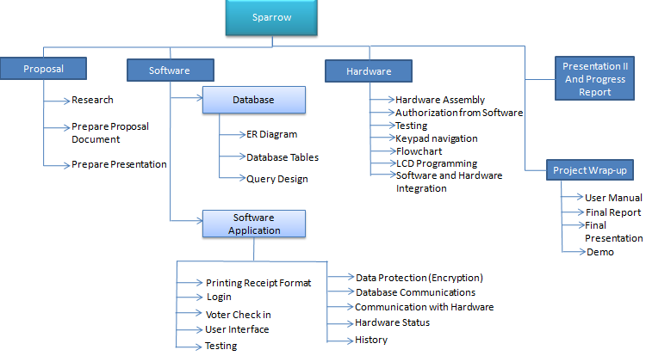
Work Breakdown Structure
Figure 5

Project Assessment and Evaluation
In order to keep track of progress and evaluate finished tasks, the JSAL team has created the following evaluation and assessment plan.
The JSAL blog will be used to document noteworthy activities or achievements. This way any team member and other users with reading access can learn about these accomplishments. The team will meet every Monday, Wednesday and Friday at 3:30pm, and on other additional days at the same time if necessary. During these meetings the team will discuss current progress and upcoming activities or deadlines. In addition the blog posts and team meetings, individual oral evaluations with a professor have been scheduled for Oct. 15, 2008, Nov. 5, 2008, and Nov. 26, 2008.
In order to be able to measure and report current progress the team has established the following assessment metrics.

- Proposal - 20%
  - Proposal Document 15%
  - Proposal Presentation 5%
- Software Development 30%
  - Software Application 15%
    - User Interface Implementation 5%
    - Application Functionality 10%
  - Database 15%
    - ER Diagram & Database Documentation 5%
    - Database Tables 5%
    - Query Design 5%
- Hardware Development 30%
  - Hardware Design 10%
  - Hardware Implementation 20%
    - Screen interface 10%
    - Keypad navigation 5%
    - Communication through UART 5%
- Project Wrap Up 20%
  - User Manual 5%
  - Final Report Document 10%
  - Final Presentation & Demo 5%

Project Design

Overview
The eVote system requires software that will allow the voter to cast their vote securely and anonymously. Software is also required in order for an administrator, like a political party representative, to verify the final vote count.
This software needs to be scalable, robust and most of all secure. In order to create this software in an organized and timely manner an evaluation of available software development models was made. The project requires a model that allows quick progress, simultaneous work in different tasks and produces documentation.

Chosen Software Design Model
The software design pattern selected for this project is a behavioral pattern. Behavioral patterns take in consideration the communication between objects identifying common patterns and realizing these patterns. Inside behavioral patterns there are several existing categories. The category selected for this project is the Chain-of –Responsibility pattern. Chain-of-responsibility pattern is based on a chain of command objects that will pass off the processing objects between them until one of the command objects can handle it. In our project, the first two command objects will be the English and Spanish Languages, the processing object will be the selected language by the voter. Another example of command objects will be the “integer” vote and mixed/candidate vote, the processing object will be the selected option picked by the voter.

Chosen Programming Design Model
The eVote project requires constant and quick progress with regards to making software. The project also requires that a considerable amount of progress be achieved in a short amount of time. For these and several other reasons the Extreme Programming agile method was selected for our project. However, one of the drawbacks of agile methods is the lack of documentation. For the capstone course the team is required to document all activities. In this way the team will stray from the conventional agile methods in order to satisfy our course requirements. The team will follow the XP methods in most other aspects like, every contributor is an integral part of the whole team, creating software in small releases, testing code against all applicable specifications and standards , pair programming and keeping a sustainable pace.
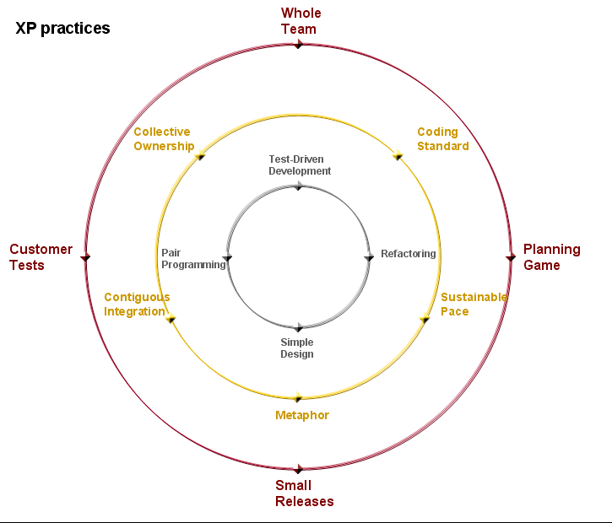
Extreme Programming (XP) Practices
Figure 6

Model Design Decisions
Other common development process models were considered for this project, but were rejected because they did not meet different needs. The Prototype model was considered since it requires a semi-functional product at the end of every cycle. However, this model requires that you finish one cycle in other to plan for the next. Due to the unyielding schedule we have, we cannot leave planning for a later stage of the schedule, so this model was rejected. We also considered using the Cascade model, but our project requires that multiple tasks be done simultaneously. The cascade model, would not allow us to begin a process without finishing a previous process, and this could delay progress. Finally, we considered a Concurrent (Issue-Based) model since it allowed for analysis, design and coding to be done at once. This seemed attractive to us since we have four team members that need to stay productive at all times. However, this model was also removed from our options since planning for concurrent processes and planning the effort required is extremely complicated and time consuming.

Design Goals

Proposal
All members of the JSAL team will formally present a project proposal on Wednesday, September 12, 2008 to both Capstone Professors and other Capstone teams. The presentation should have a length of no more than 20 minutes and allow for a 10 minute Q&A session.

Oral Exams
Each member of the JSAL team will undergo an individual oral exam on the following dates:
Oct. 15, 2008, Nov. 5, 2008, and Nov. 26, 2008.

Final Prototype
All members of the JSAL team will formally present a functioning prototype on a designated date to professors and presentation attendees. The prototype (Sparrow) will be a version called of the voting system design. The prototype must have all the functionality specified in the prototype design of this document.

Required Project Activities
In order to complete the prototype for the Sparrow system, the team will need to carry out the following activities:
- Install all SQL related Software
- Install Microprocessor development kit tools
- Microprocessor Training and Research
- Hardware Integration
- Soldering kit preparation
- Database Activities
  - Create Queries
  - Create and fill database tables
- Prepare hardware and software designs
- Organize a project schedule
- Develop Sparrow firmware

Deliverables
Table 4 has the deliverables planned out by start and end date for each item throughout the semester.
Deliverables | Duration | Start Date | End Date
Proposal and Oral Presentation I | 12 days | Mon 8/25/08 | Wed 9/10/08
Software Prototype | 53 days | Thurs 9/11/08 | Wed 11/26/08
Sparrow Prototype | 53 days | Thurs 9/11/08 | Wed 11/26/08
User Manual | 2 days | Thurs 11/27/08 | Fri 11/28/08
Oral Presentation II and Progress Report | 6 days | Thurs 10/24/08 | Wed 10/29/08
Final report | 4 days | Fri 11/28/08 | Mon 12/1/08
Final Presentation | 4 days | Tues 12/2/08 | Fri 12/5/08
Deliverables Table
Table 8

Raven Design

Voting Module

Overview
The Raven design refers to the full scale design of the eVote system. The voting module consists of the actual voting process. Any registered voter that has been authenticated and cleared to participate in the elections, will be allowed to vote using the eVote system. The system will discard the paper ballot format and provide an interactive touch screen experience that will contain graphics. The graphics will represent each candidate’s affiliation as well as their running position in full color. The voter will also be able to provide their write in choices by selecting an option to display an onscreen keyboard which will require touch interactions and once the voter has typed in the name of their nomination, the voter can then move on to the next category of the ballot. The interface will provide the option to vote for mixed party candidates or all members running particular to a specific party. The voter will then be able to submit their vote and receive a print out with a summary of their votes with the corresponding barcodes for their choices. The barcodes will be used as a backup counting method in case the electronic results are found to be invalid. The voter’s choices will then be sent to a software application that then relays this information to a database where detailed information of the votes will be stored.

Requirements Analysis

Hardware requirements
The software needs to be able to interact with the voting device and acquire the voting selections made. In order to make the device compatible with the software, a driver will be developed. A physical device that can enable voters to cast their choices, and communicate this choice to a database is required. The interactions with the Raven version will be completely through touch screen interactions so the physical device requires a touch panel.
Additional hardware requirements include the systems that will act as servers for Raven. This is necessary so that the system can have a dedicated machine to the management of data used for the Raven voting process.

User Requirements
The voting process will be a simple procedure so that any demographic can adjust to the newly developed voting system. The interface used on the device needs to abide by usability and accessibility standards and provide an efficient user experience. To this end, the images will be developed to meet the user’s needs. The system will be in full color to help identify the political parties with their corresponding colors. Also images will be at an acceptable size for users that have impaired vision. Font considerations and text size are also taken into consideration for the eVote interactive interface. Blind and other impaired voters will require additional assistance as they have in the past paper format elections. The development for accessible voting will be considered as future work.

Restrictions
The software used for the system can only be used by an elections official due to the fact that the software allows voters to check in and have a voting kiosk assigned to them. The voter will need to be checked in by the elections official before being able to vote, because the voting devices will be locked until activated through the voter check in software.

Database Requirements
The eVote system requires two essential database designs: voting system database design and the Voter/Kiosk database design.
The voting system database design contains information pertaining to all candidates participating in the current elections. The database contains tables for Candidates, Positions, Districts, and Cities. With the information provided in this database design all necessary ballots can be created and displayed for a voter in different places. This is also the database design used for tracking the number of votes given to a specific candidate.
The voter/kiosk database design was made in order to provide a means for administrators to verify if a voter has already participated in the current elections. The database design contains two main entities: voters and kiosk. With these entities and their corresponding attributes an administrator can determine if a user has already participated in the election and the administrator can also associate a kiosk to a voter. This relationship is helpful when assigning a kiosk to a voter and also as a way to track who has used which kiosk. This can aid in protecting kiosks and determining who is responsible for any kiosk damage.
It is important to point out that these two database designs are in no way connected and there will be no method in which the design will allow anyone to decipher who a voter cast a vote for.
The information stored in these two designs needs to be backed up and protected in order to protect two valuable sets of information: the voting count and the voter personal information. Database replication can help secure this information with a master/slave relationship between the original database and copies. If the master database becomes unavailable or compromised, the slave databases will take over any functions of the master database and will provide any necessary information. Synchronous replication would guarantee that no loss of information occurs as storing any information would happen in master and slave simultaneously.
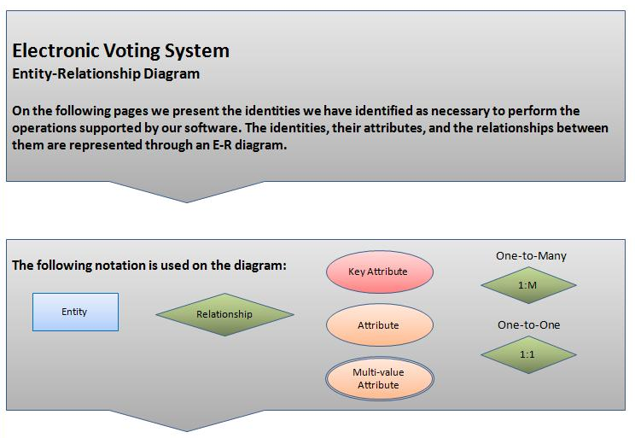
Entity Relationship Diagram Legend
Figure 7

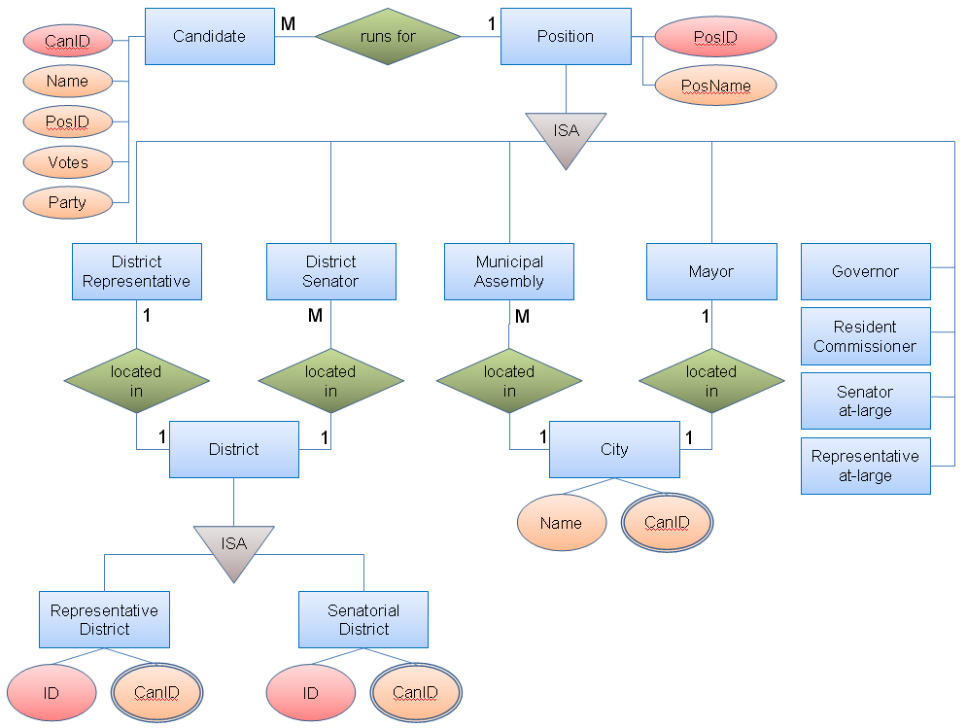
Raven Voting System ER Diagram
Figure 8
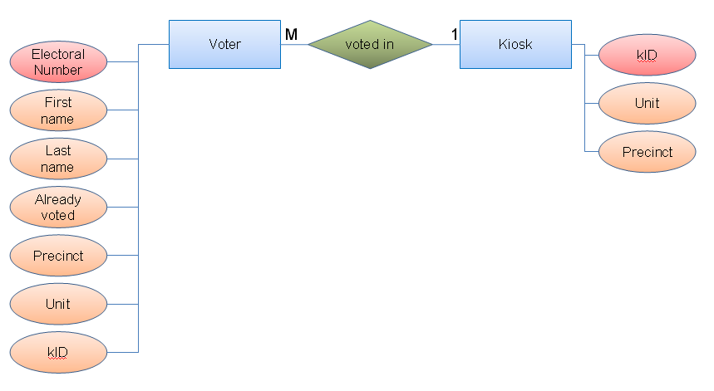
Raven and Sparrow Voter Kiosk ER Diagram
Figure 9

Security Requirements
To prevent the results of the election from being viewed and understood by anyone else other than selected officials, the information sent to the database will be encrypted. Only special software used to acquire this information will be able to decrypt it.

Software Trust Issues
Since elections is a public event, it is important to establish a specific level of trust to the programming behind the votes made with the eVote system. After completion of the voting software has been completed, it will be made open source to prove that JSAL’s work is neutral and unbiased.
The topic of corruption affecting the electronic voting systems was covered extensively in the HBO Documentary called “Hacking Democracy”. The film “exposes the vulnerability of computers - which count approximately 80% of America's votes in county, state and federal elections - suggesting that if our votes aren't safe, then our democracy isn't safe either.”[Hacking Democracy ref #] For this reason it is important that the eVote system, in its Sparrow and Raven versions, maintains the utmost transparency both in code and in information management. Our system seeks to stand out with the transparency with which it is developed and the effort spent in securing information and maintaining voter anonymity.

Ballot Design
A similar design to the physical ballot will be used to allow a familiar interface that any user with voting experience is accustomed to. EVote will provide small tutorials for users who have no experience so that they are not confused when the moment comes to vote.

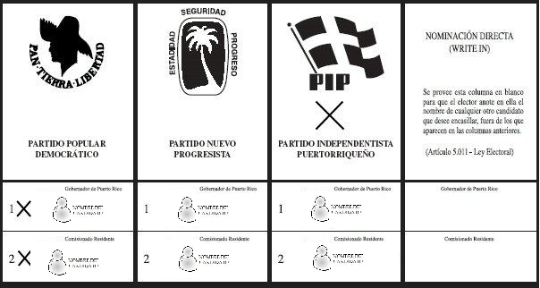
Governor Voting Ballot – Original Taken from the Elections in Puerto Rico website [18]
Figure 10

Figure 10 shows an example of the governor ballot which was used to design the interface allowing for a more familiar look. Figure 11 depicts the legislative ballot and Figure 12 shows the municipal ballot.
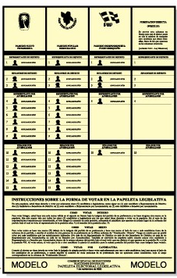
Legislative Ballot – Taken from Elections in Puerto Rico website [18]
Figure 11

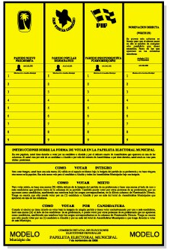
Municipal Ballot – Taken from the Elections in Puerto Rico website [18]
Figure 12

The design of the electronic ballots will take the current format of each ballot and implement them in a similar fashion which should in essence lower the learning curve. This design will allow the voter to have mixed votes or simply vote for all party members in one column if the icon is selected.

Design Decisions

Decision Background
The goal is to design an interface in which a user can pick up the device and interact with it easily during the time of the elections. The user interface will hopefully improve the user experience from past elections and provide a more modern feel while voting.
There are many trade-offs involved with the development of the voting of EVote. In order to maintain the budget, economic hardware components will be purchased to assure that the prototype can be built within a reasonable spending limit.
The team researched various online hardware products available online. Each product varied in features, price and quality. Analysis of the hardware trade-offs were necessary to verify which items were viable for the design of Raven. Research was done to verify the feasibility of a touch screen device that would be able to communicate with a computer to receive images need for the on-screen ballots. The design would depend heavily on the microprocessor chosen for the project since there are many that do not support computer to hardware communication.
The central hardware device needed is the microprocessor since it will be managing the communication between all the devices involved in the project. The liquid crystal display screen (LCD) will be connected to the microprocessor and depending on the type of screen used there will be a higher or lower amount of pins that require connection to the microprocessor. In this project, it is desired to have a color LCD screen so that images can be provided to serve as a visual aid in the voting process.
The touch panel possesses a certain amount of pins that may vary from panel to panel. There various kinds of touch panels such as the resistive, infrared, capacitive and surface acoustical wave technology. The resistive technology uses the user’s touch pressure to cause two thin screen components to touch each other causing ground. The coordinates of the touched area are detected with a control device that uses this information to respond with programmed commands. The infrared screen technology involves miniature transmitters that emit IR beams across the screen. Upon interruption of the beams due to contact by a finger or other object, the coordinates of this contact are detected. The last but not least researched touch panel technology is the capacitive screen technology. This technology uses a screen with a slight electrical current that when a conductive object (such as a finger or conductive stylus) comes into contact with the screen, a capacitive coupling is created that causes a current flow at the touched area. The contact coordinates are acquired in a similar manner as the resistive screen technology [19].
After comparing market prices, the panels using resistive screen technology are the most economic and easy to use on the user end. Due to our budget, the resistive technology is preferred. Due to the need of a write in feature where the user can enter a name into the eVote device, an on screen keyboard will be implemented to take full advantage of the capabilities that the touch screen provides.
The microprocessor selected needs to have the capability of working with all of the hardware components. Having this in mind, it is necessary for the microprocessor to possess enough pins to provide connections to the components needed.

Microprocessor Design Decisions
For this design, it is necessary to acquire a microprocessor that supports high resolution. This would allow implementation of color graphics. Having color related information stored into a microprocessor will consume more space than with code referring only to monochrome pixels. With this in mind, it is important to consider microprocessors that have bigger amounts of ROM (Read Only Memory) space for the code that goes into the programming of color graphics. Using an LCD (Liquid Crystal Display) monitor that has touch screen requires enough coding space to be able to implement the functions that are to execute when an area of the screen is touched. Also an important factor is the amount of ports available since the connecting hardware components that interact with the microprocessor depend on this. One important aspect to consider is the UART (Universal Asynchronous Receiver / Transmitter) which is needed to allow communication between the microprocessor and computer software [20], [21].
A driver will need to be developed to allow the computer to recognize the hardware and understand how to communicate with the eVote device.

 | STR711FR2T6 | STR712FR2T6 | LM3S1968
I/O Pins | 40 | N/A | 52
Max Operating Frequency | 50MHz | 96 MHZ | 50 MHZ
Voltage Supply Input | 3.3V | 3.3V | 4.37–5.25 V
RAM | 64K | 96K | 64k
Flash | 256K | 512K+32K | 256K
Timers | 5 | N/A | 4
UART | 4 | 3 | 3
Microprocessor Comparison Table - Data Acquired from Spark Fun website [20] , [22] , [23]
Table 9

The best choice is the LM3S1968 since it supports more pins as well as a 32-bit RISC (reduced instruction set computer) which can possess a wider array of programmable options. The on board memory seems quite enough to allocate the necessary code for the eVote functions and images.

LCD Screen Design Decisions
Monitor | Display Size | Price | Comments
Megavision MV155UB 15" Touchscreen LCD Monitor - 500:1, 12ms, 1024x768 (XGA), Black | 15 “ | $299.99 | Compatible also with IBM and Apple
Synaps S15TSM/T5AV 15-inch Touch Screen Monitor | 15 “ | $429.00 | For use in retails and point of sales, educational, industrial, scientific or manufacturing, office automation, self service kiosk, inter-active marketing and advertising. Easy to operate and accurate with a stylus, gloved hand, pen, or direct contact
Synaps S17TSM/T7AV 17-inch Touch Screen Monitor | 17” | $529.00 | For use in retails and point of sales, educational, industrial, scientific or manufacturing, office automation, self service kiosk, inter-active marketing and advertising. Easy to operate and accurate with a stylus, gloved hand, pen, or direct contact
Gvision P15BX-AB-459G 15-Inch LCD Touch Screen Monitor with Built In Speakers (Black) | 15” | $399.99 | Support for plug & play
10.4 Desktop TFT LCD Monitor w Touch Screen + VGA | 10.4” | $199.99 | Too small.
LCD Screen Comparison Table [24]
Table 10
The most efficient monitor would be the mega vision monitor, which has a high resolution as well as an efficient display size. Coincidentally, touch screens are easier to find for the size of the monitor.

Printer Decisions

Printer | Price | Resolution | Paper Storage | Speed | Duty Cycle
HP LaserJet P1006 Printer | $179.99 | 600 x 600 dpi | 150 | 17 Pages per Minute | 5000 pages
HP LaserJet P1005 Printer | $129.99 | 400 x 600 dpi | 150 | 15 Pages per Minute | 5000 pages
HP LaserJet P1505 Printer | $199.99 | 600 x 600 | 250 | 24 Pages per Minute | 8000 pages
Samsung ML-1630 Monochrome Laser Printer | $ 199.95 | 1200 x 1200 | 100 | 17 Pages per Minute | 5000 pages
Printer comparison Table
Table 11
The recommended printer is the HP LaserJet P1505. The reason for recommending this printer is basically the high paper storage and the high speed for printing. Also, it has a great duty cycle.

Touch Screen Decisions
This hardware will allow the user to interact directly with the device selecting their voting choices depending on the coordinates of where the screen was touched. The touch screen will allow the write in feature to be physically interactive with the software. A touch screen keypad will be implemented to allow the write in to be typed in.

Product Name | Price | Type | Size | Location | Item Information
PSP Touch Screen | $23.95 | 4-Wire resistive | 4.3” | Sparkfun.com | Too small for a Large  LCD Screen
5-WireTouch Screen | $83.00 | 5-Wire Resistive | 15.1” | Digikey.com  Catalogue | 400211-02
5-WireTouch Screen | $107 | 5-Wire Resistive | 19.2” | Digikey.com  Catalogue | 400225-01
5-WireTouch Screens | $59 | 5-Wire Resistive | 10.4” | Digikey.com  Catalogue | 400302
Touch Screen Comparison Table
Table 12

Table 6 has many different options for touch screens but due to the selected LCD monitor seen I table 5, a touch screen is not necessary because the monitor already has touch screen capabilities.

Program Design

Raven Flowchart
The flowchart represents the flow of execution of the Raven system. When the device is turned on, it will establish communication with a computer through its software. This is important so that the voting summaries can be sent into the database for tallying purposes.
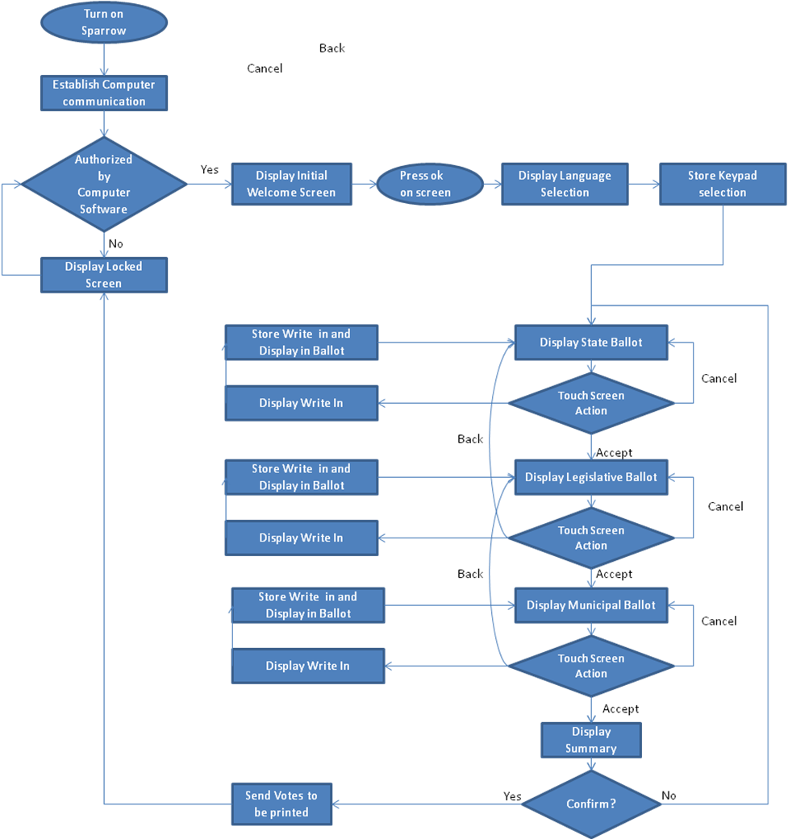
Raven Device Flowchart
Figure 13

Raven Interface design
The eVote system will implement the three ballots used in today’s elections. When the user arrives at the voting booth, they will encounter an initial screen upon being authenticated by an elections official shown in Figure 14.

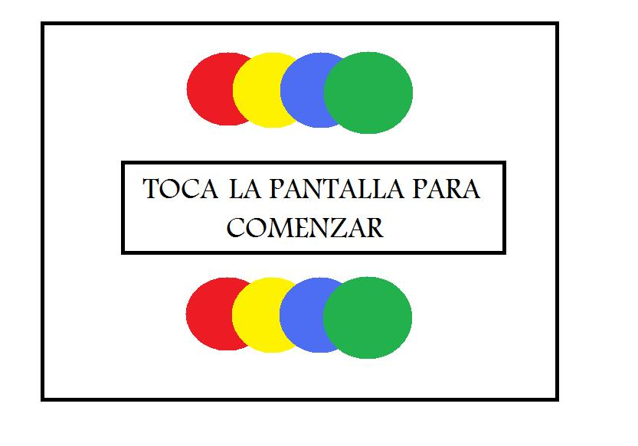
Initial Screen of eVote
Figure 14
Once touching the screen, the voter is rapidly directed to the first ballot. However, if not authenticated first by an elections official the screen will display what is shown in Figure 15.

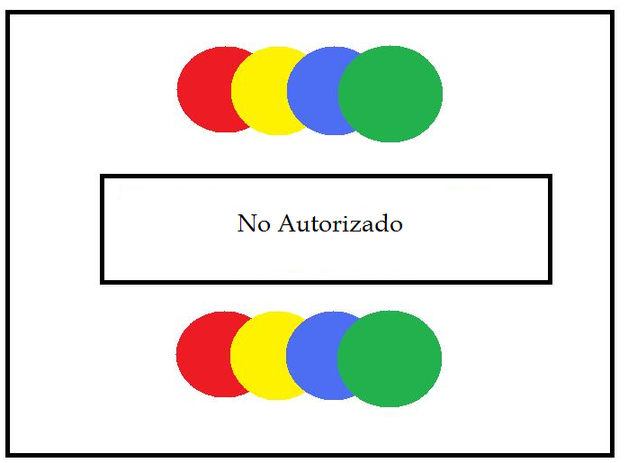
Locked Screen of eVote
Figure 15
They will have the option to select one candidate of their choice for each position in the ballot shown in Figure 16. To perform a write-in the voter can simply touch the right most columns where gray circles are located. After touching this area, a write-in touch interface will appear in the form of a keyboard.

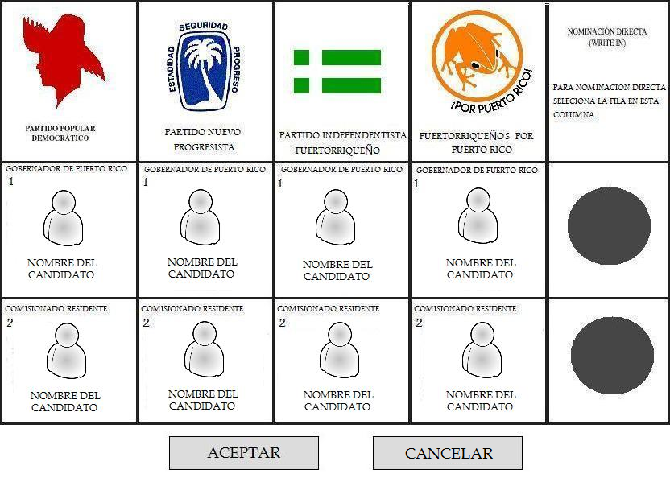
Governor Screen of Raven
Figure 16
Write in will have an onscreen keyboard appear allowing you to type in your choices.

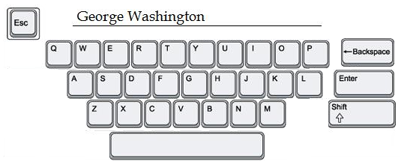
Touch screen keyboard screen on eVote –Original image taken from Seoconsultants web page [25]
Figure 137

Once the voter has typed in their write-in, they can simply press enter and the write in choice will appear in the corresponding row and column as seen in Figure 18.
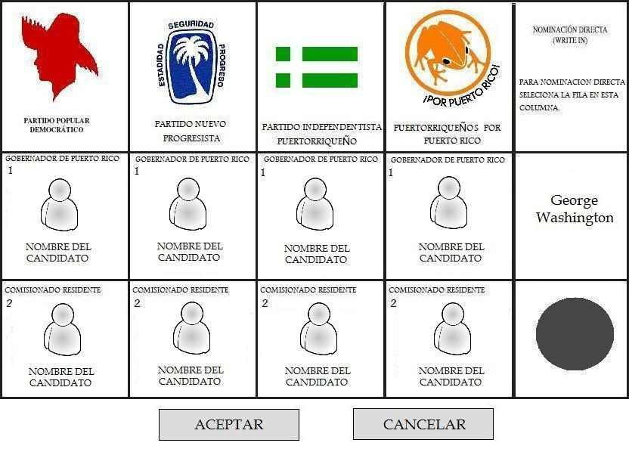
Governor Ballot – Write in
Figure 14
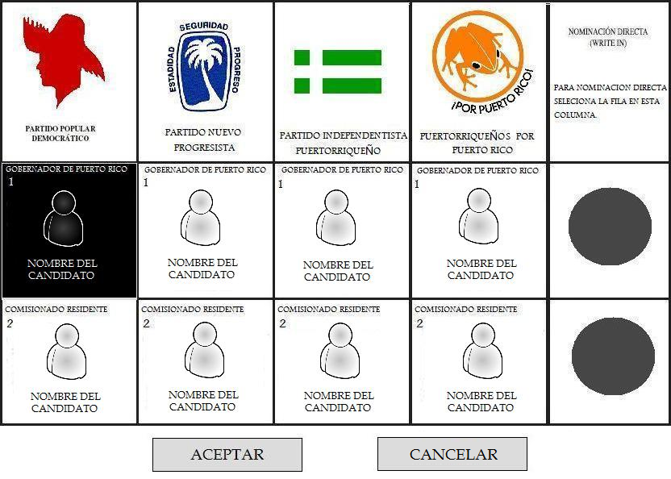
Item Selected – Governor Ballot
Figure 1915
Once you select a candidate the write in will be removed and your selection will be highlighted as seem in Figure 19. After making the corresponding selections, the voter must press the accept button to continue to the next ballot. Pressing cancel would nullify the selection made and return the screen to its original state.

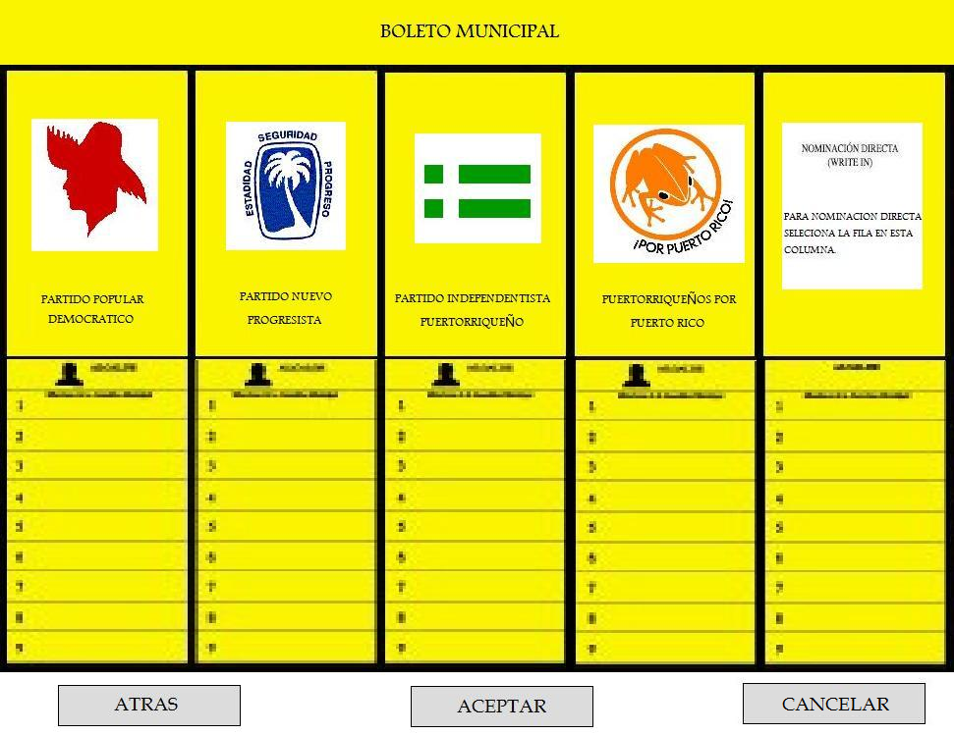
Municipal Ballot Screen
Figure 20
The next ballot shown in Figure 20 is the municipal ballot. Voting on this ballot will behave in the same manner as the first ballot. Selecting a mayor will highlight your selection and if you select a row in the write in column, a key board will be displayed allowing you to continue typing in your choice for that particular voting position.
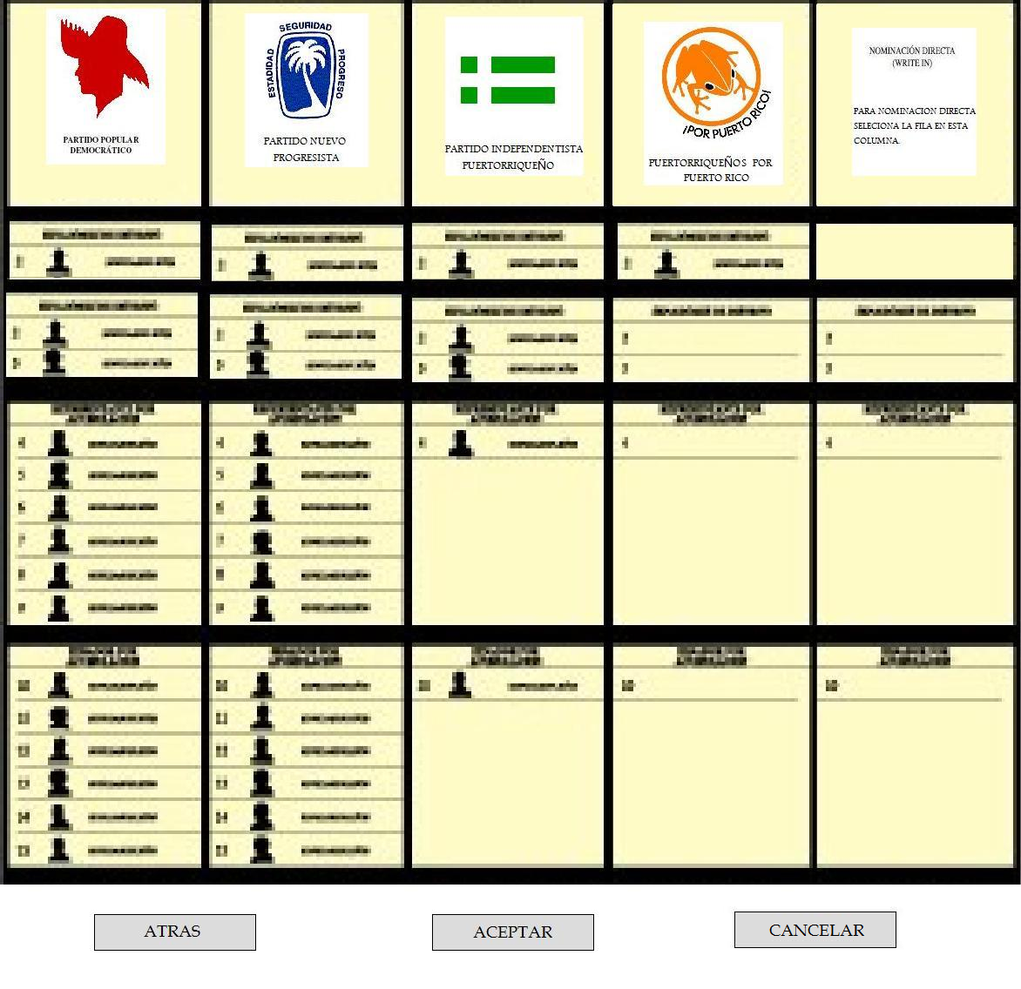
Legislative Ballot Screen
Figure 16
Figure 21 shows the third and final ballot to be implemented which is the legislative ballot. Interactions on this ballot are of the same method as the previous ballots.
After the first ballot if the user decides to return to a previous screen, they can simply click the back button labeled “ATRAS” in the ballot Figures 20 to 21 Once the voter has selected the accept button on this ballot they will be directed to a summary screen seen in Figure 22, where they will be briefed on their voting choices. Here they can decide if everything is in order, if not, they can simply click back until they reach the ballot they wish to modify.
Each ballot will still remember the selections made to them so by pressing the back button, the voter will not have to “re-vote”.

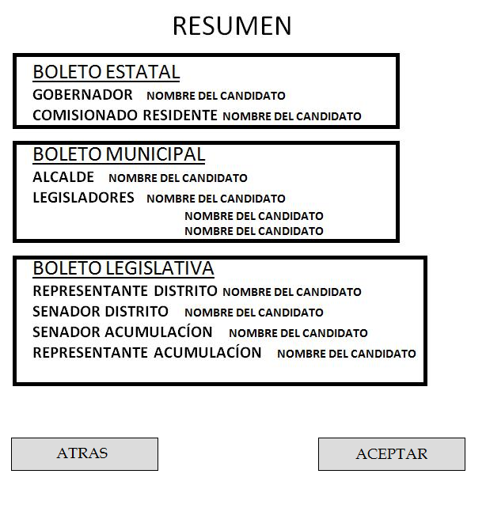
Voting Summary Confirmation
Figure 22
The summary will contain the votes in blocks that correspond to each ballot to keep an organized look.

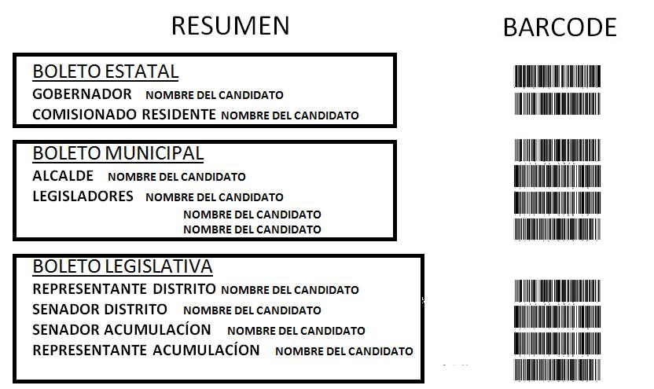
Summary Printout Receipt
Figure 23
Once the user has accepted the voting summary, which effectively submits their votes, a print out with barcodes that correspond to the voting selections will be made available by a printer within the current voting booth. The barcodes will have specific information that refers to the position, political party and name of the candidate.

Program Design
The voting check-in software for Raven and Sparrow are the same since both versions require the voter to check in with an elections official and have a voting booth assigned to them electronically, which is the purpose of the software. A more detailed explanation of the program design can be found in section 7 (Sparrow) of this proposal.

Software Design Considerations
One of the most important aspects of the software is the protection of the sensitive voting data. This can be done by creating a key that encrypts the information in the database and no one without knowledge of this key will be able to decipher the encryption.

Hardware Design Considerations
The hardware design consists of a touch-screen LCD which will serve as an interactive interface of eVote. The LCD will connect to the microprocessor so that it can communicate with the computer software relaying the vote information. The USB (Universal Serial Bus) connection - depending on the method of computer communication- may behave as a serial port and a corresponding driver will have to be developed to provide the computer with a means of how to interact with the eVote device. The microprocessor chosen contains a UART port with is used to establish computer software and hardware intercommunications.
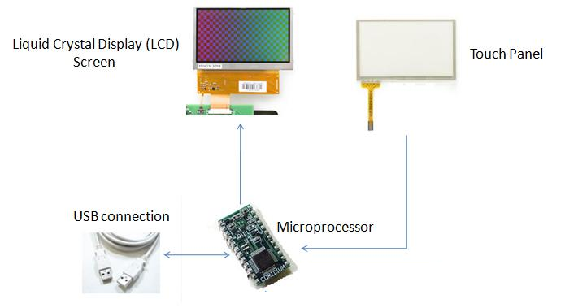
Hardware Design Layout – Images taken from Spark Fun [26]
Figure 24

Tallying Module

Overview
The Raven system will provide an application for counting the votes for the case of re-counting for a revision of the results. The counting application will provide an interface so that a person can scan the barcodes printed on a ballot using the barcode scanner. The process of re-counting the votes will be the same process that is being followed today for counting the votes in which there is an authorized representative of each party, the only change will be found in the counting of the votes. Instead of counting the votes manually, the votes will be scanned and the application will count the votes. When all the ballots are counted the application will provide an option to print a document with all the results and a signature space to validate and sign the results. By scanning the votes, instead of counting them manually, there will be a reduction in time of processing the votes as well as precise results.

Requirements Analysis

Interface Requirements
A user interface is required in order to manage the scanned results. The user interface will count the votes and will provide a print copy of the results. As a hardware requirement, the interface must be able to interact with barcode scanner.

Input and Output Requirements
An input for the module will be the barcode code. This input will be produced by the barcode scanner in text format. The output of the module will be the result report in which the user will act as the consumer. The output will be text formatted.

Functionality Requirements
The module must have the following two functionality requirements: Capture barcode code from the barcode scanner and Produce results and present then to the user. The Capture of the code from the barcode scanner is required to count the votes. The production of results and presentation of them to the user is required to produce the results report that will be printed once the ballots are scanned.

Restrictions
The tallying vote application will be accessed only by authorized personnel to count the votes.

Design Decisions
Why use barcode? What type of code should be used? What type of scanner? Barcodes are representation of data in an optical format that can be interpreted by an optical machine (barcode scanner). Barcodes are used to implement Auto ID Data Capture (AIDC) systems. This type of system improves the speed and accuracy of computer data entry. Therefore, if there is the need to re-count the votes, the use of the barcode will improve the speed as well as the accuracy of results.
There exist several types of barcode codes as well as several types of barcode scanners. For selecting a barcode code, the type of image and the character set are the primary characteristics to take in consideration. For this product the type of image selected was linear instead of 2-D image. 2-D images are used when complex data representation is need. Since the barcode will be used only to represent a candidate, the linear barcode comply the need. Also, linear barcode scanner is not as expensive as 2-D barcode scanners. After taking in consideration that linear image is to be used, the character set is to be compared. The barcode code 39 is the one selected for the project. The reason for selecting this particular code is based on the fact that between the codes that provided characters as well as numbers, Code 39 fonts can be downloaded free from the internet.
The type of barcode scanner will depend on the type of barcode code selected. Since the code 39 is a linear code, either a Laser Scanner or a CCD (Charged Coupled Devices) Scanner (also called linear imagers) will work for the application. Since laser scanner can also read 2-D codes, this type of scanner is more expensive than a CCD Scanner. Therefore, a CCD (linear) scanner will be used for the application. When selecting a scanner there are several characteristics to take in consideration. For example, the Operating System supported. Since the whole eVote system will be developed to support Windows Vista, the scanner selected needs to support this operating system. Scanners power consumption and reading distance will have effect on the prices of scanner. Since the project will be supported by students’ finances the cheaper scanner was selected to be used on the application.

Barcode | Character Set | Applications / Comments
Code 128 | All ASCII characters and control codes | Widely used: excellent for any applications
Code 39 | Uppercase Letters A-Z;  Numbers 0-9;  Space - . $ / + % | In very wide use for many types of applications
Extended Code 39 | All ASCII Codes and control variables | Uses pairs of characters to encode non-standard symbols; wasteful of space
Code 93 | Uppercase letter A-Z; Number 0-9;  Space -. . $ / + % | A more compact cousin of Code 39, not as widely in use
Barcode Comparison Table
Table 13

Barcode Scanner | Type | Operating System | Power | Reading Distance | Price
IDAutomation USB Barcode Scanner  with DataBar and PDF417 | Linear CCD | All versions of Windows (Vista Included) | 5 VDC +-5%  120mA current consumption | Up to 8" | $119
EZ One Shot® USB CCD Barcode Scanner By IDTech | Linear CCD | Windows (Vista not supported) | +5 VDC ± 5%  85 mA ± 10 mA current consumption | 1/2” to 1" | $69
ID Tech EconoScan | Linear CCD | Windows (Vista not supported) | +5 VDC ± 5%.  65 mA ± 10 mA current consumption | 0” to 4.72” | $89.20
Xi3000 Barcode Scanner | Linear CCD | Windows Vista, XP, or 2003 | +5V +/- 10%  75 mA current consumption | 0.59” up to 10” | $189.00
Barcode Scanner Comparison Table
Table 14

Program Design

Program Screens

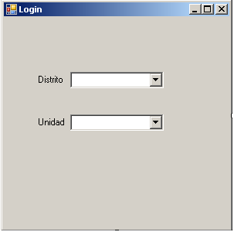
Required Login Parameters
Figure 17

The Login Screen will appear when an authorized user opens the tallying application. The user will enter the district and unit for which he will scan for tallying the votes.

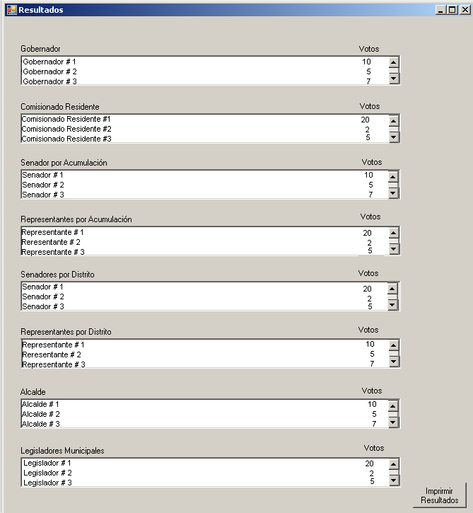
Tally results Screen
Figure 26

As the user scans the ballots, the results will be displayed. Once all the ballots are scanned the user will click on the print results button to print out a report.
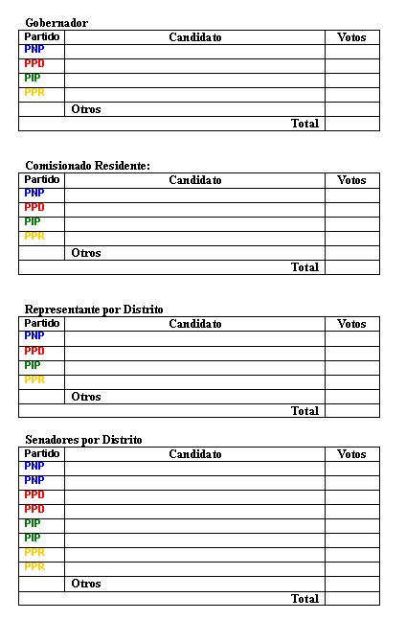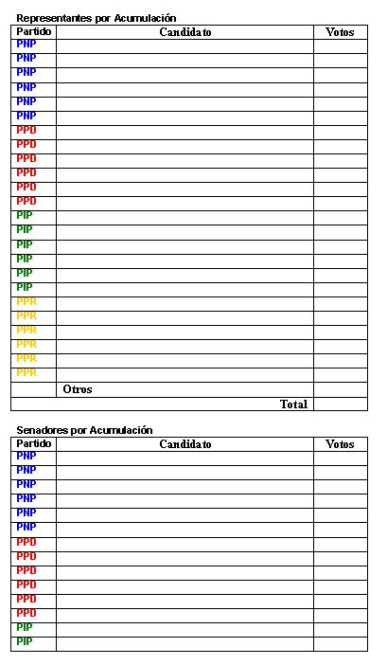
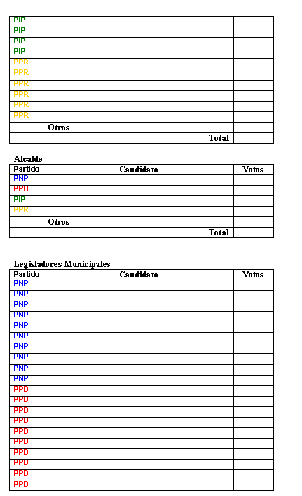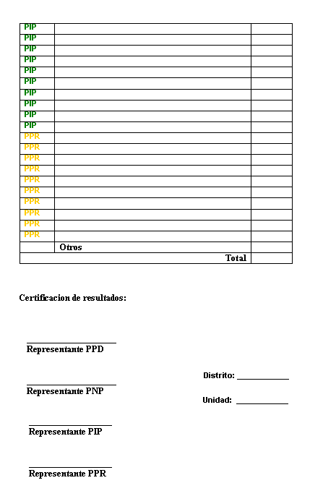
Figure 27 – Tally Results Printout
The printing report will be signed by a representative of each party to approve the results.

Sparrow

Overview
Sparrow is the scaled down version of the Raven project and will be a 3 month project which will serve as a prototype to the full version previously discussed. This version will have a smaller scope in terms of hardware and software requisites. A smaller monochrome LCD will be used with a variant of the MSP430 microprocessor. The touch screen interaction will be replaced with a keyboard interface and only one of the three ballots will be implemented.

Database Design
The database will have the same ER diagram with the exception of the choices available for voting. In Raven the ER diagram includes the legislative ballot and municipal ballot, but for Sparrow the ER diagram will only work with the state ballot as seen in Figure 28.
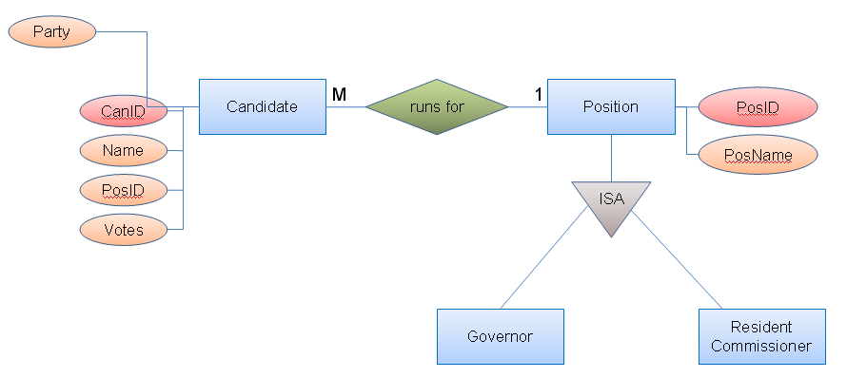
ER Diagram for Sparrow Election Choices
Figure 28

Design Decisions

Design Overview
The design requirements do not change in Sparrow. The following design decisions for LCD screens, microprocessors and keyboard considerations

LCD Design Decisions
Manufacturer | Price | Size | Color | Resolution | Additional Details | Item Number
LCD - Sharp Microelectronics | $152.72 | 3X3“ | Yes | 320X320 | Expensive, and will not allow easy purchase of additional screens in case they get broken. | Digikeys  425-2479-ND
Sparkfun – Monochrome LCD | $19.95 | 2X2.5” | No | 64X128 | Seems too small to provide an efficient interface. | Sparkfun  LCD-00710
Sparkfun –  Blue and White LCD | $59.95 | 4X5” | Only white and background is blue | 160X128 | Uses white pixels with a blue background | Sparkfun  LCD-08799
Sparkfun –  PSP LCD | $60.95 | 4.3” | Yes 24 bits | 480X272 | Requires connector for 24 pins of LCD to interface with microprocessor | Sparkfun  08335
All electronics B/W LCD | 18.50 | 5.8" x 4.58” | No B/W | 256 X 128 | Requires connecter and soldering | Allelectronics.com  CAT# LCD-101
LCD Comparison Table
Table 15
The team decided to select the LCD from all electronics due to it’s size and resolution for such a low price. If you compare with the LCD’s from the spark fun website, it can be noticed that the size is smaller and has less resolution for three times the price. Sparrow will not implement a color screen interface, so money can be saved from a monochrome design.

Printer Decisions
The same printer decision made in Raven will apply to Sparrow, since the need for a high quality printer capable of printing barcode is also a necessity for the voting receipts.

Microprocessors Decisions
 | MSP430FG4619 | MSP430F148 | MSP430F149
Frequency(MHz) | 8 | 8 | 8
Flash | 120 KB | 48 KB | 60 KB
RAM | 4 KB | 2 KB | 2 KB
GPIO | 80 | 48 | 48
Pin/Package | 100LQFP,113BGA MICROSTAR JUNIOR | 64LQFP,64QFN,64TQFP | 64LQFP,64QFN,64TQFP
ADC | 12-bit SAR | 12-bit SAR | 12-bit SAR
Other Integrated Peripherals | 2 DAC 12, 3 Op Amp, Analog Comparator, DMA, SVS, Hardware Multiplier | Analog Comparator, Hardware Multiplier | Analog Comparator, Hardware Multiplier
Interface | 1 USART (SPI or UART), USCI (UART/LIN/IrDA/SPI and I2C/SPI) | 2 USART (SPI or UART) | 2 USART (SPI or UART)
Timers | 1 16-bit (3CCR), 1 16-bit (7CCR), 1 Watchdog/ Interval, 2 8-bit | 1 Watchdog/Interval, 1 16-bit (3CCR), 1 16-bit (7CCR) | 1 Watchdog/Interval, 1 16-bit (3CCR), 1 16-bit (7CCR)
Microprocessor Comparison Table
Table 16
Due to the graphic interface, the design took into consideration a microprocessor that could handle a hefty amount of code for pixel coordinates to be hardwired into the system which would used to create images onscreen. Although the images used in monochrome style are usually only a few bytes, it was considered a design decision to provide additional space to ensure that the entire code can fit into the flash memory. Also a useful factor is the ram, which can be used to store information as well, but will not be necessary in the scaled down version since all images and interfaces will be hardwired. The best microprocessor would be the MSP430FG4619 microprocessor due to it’s larger amount of flash memory allowing for more code to be created. This serves as a good base for the prototype since the final product may even be less demanding of hardware specifications. When this analysis has been made, then the hardware can be scaled down to save more money on components if it is possible.

Keypad Navigation
Sparrow will be using a keypad to navigate throughout the different available choices and screens. The keypad will be used to make on screen selections which will direct the user to a different screen. The keypad will have to be taken into consideration when programming the functions to change screens after certain navigation events take place.

System Design
The system design remains the same with the exception of the tallying module which will not be implemented in Sparrow.

Program Design

Program Design Screens

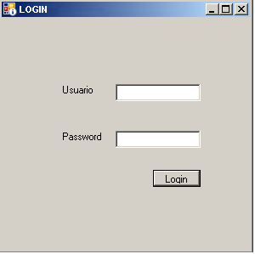
Login Screen For Sparrow’s Management Software
Figure 29
When an authorized user opens the Registration Application, a login window will appear. The user will enter his user name and password and will proceed to click the Login Button.
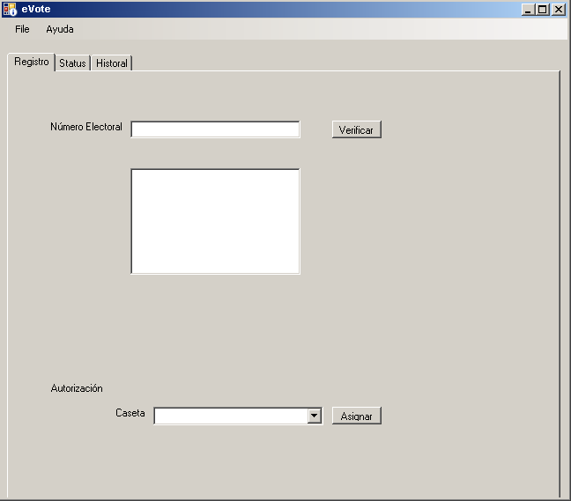
Sparrow’s Voter Assignment Screen
Figure 30
The “Registro” tab of the e-vote Registration application is used by an authorized user to check if the voter has not voted yet or if he is authorized to vote. The user will enter the “Numero Electoral” ID Number and will click the “Verificar” button. The status of the voter will appear on the box below. If the voter is allowable to vote then the authorization part of the tab will pass from read-only to write. The user then will select a station “Caseta” to assign the voter to that station, and will proceed to click the “Asignar” button.
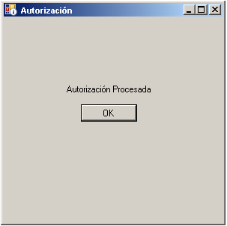
Sparrow’s Confirmation Pop-up
Figure 18
If the authorization of the voting station is successful a pop-up window will appear to confirm the authorization.
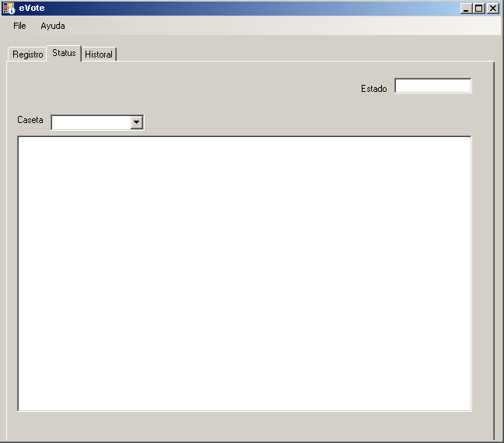
Sparrow’s Status Screen
Figure 19
The status tab is used for verifying the status of the connection of the device in each kiosk. It will also provide information related to the printer in each station.
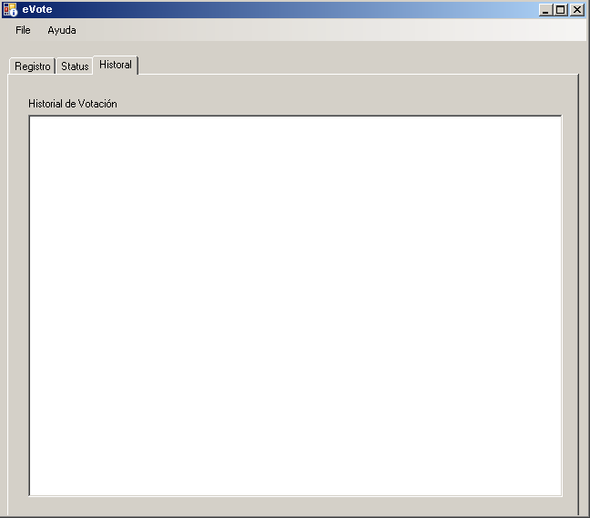
Sparrow’s History Screen
Figure 20
The “Historial” tab will provide the history of the voters that used that terminal. The purpose of this tab is to track the users in case any damage is caused to a device.

Sparrow Flowchart
Figure 34 shows the flowchart for Sparrow which depicts the possible navigational choices that can be taken as well as the possible election choices. When the voter selects mixed, they will have the option to select a party and then a candidate, or if they only wish to vote for the candidate, they can simply choose none of the provided parties and continue on to the candidate selection.
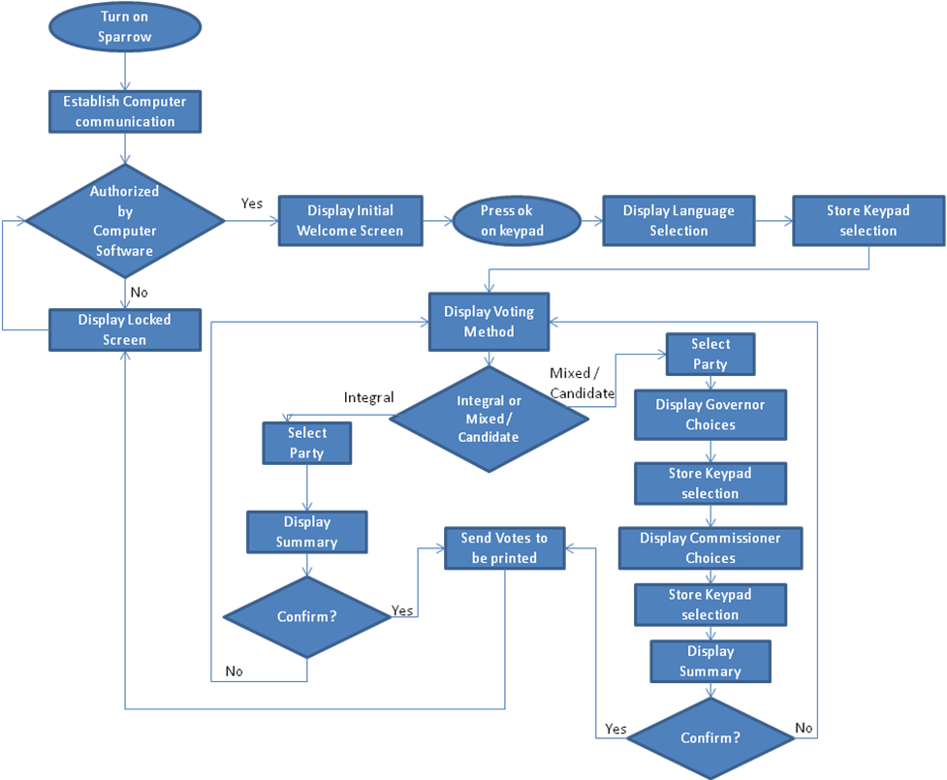
Sparrow Flowchart
Figure 21

Sparrow Interface Design
Before the voter can begin casting their vote they must be checked in. In the check in area, the elections official will assign the voter to an empty booth which will have been activated by the voting management software. If the voter has not been cleared to begin voting they will encounter the image shown in Figure 35, which impedes any further action.
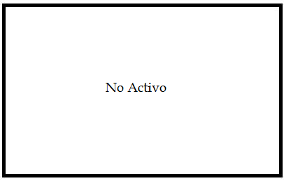
Sparrow’s device inactive screen
Figure 22
Due to a recent change of events, the ballots are now being made in both English and Spanish. Our solution for this is to provide a new on screen choice shown in Figure 36, to select a language which will alter the rest of the voting experience to the language selected.

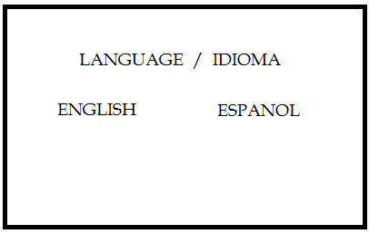
Figure 23
Once the voter has been cleared, the screen will change allowing the voter to interact using the keypad.
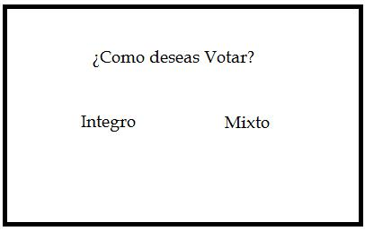
Sparrow’s device voting option screen
Figure 24
When the voter has made a selection whether it was to vote “integro” or mixed, the choice will be highlighted in a similar fashion to what is shown in Figure 38.
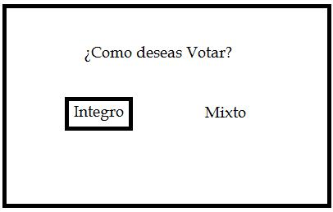
Making a Selection
Figure 25

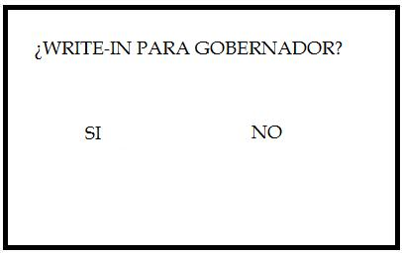
Write-In option confirmation
Figure 39
Once the voter selects the option for a mixed vote decides not to write in a direct nomination, the next screen will appear allowing selection of the 4 possible governor candidates as seen in Figure 40. Using the keypad will allow the voter to move up or down to select a candidate, once a decision has been made, they will need to press the ok button to proceed. The currently highlighted choice will have a black circle adjacent to it.

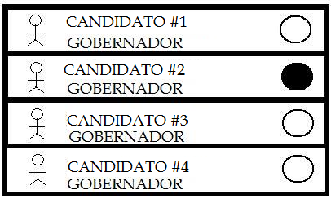
Candidate Selection
Figure 40

If the voter had selected an Integral vote, then they would be presented with the screen shown in Figure 41 which allows the voter to select a political party.

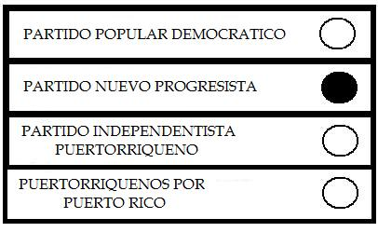
Political Party Selection For Integral Vote
Figure 26

Once the voter has chosen they will be asked to confirm their vote as depicted in Figure 42.

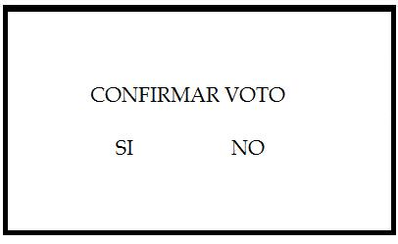
Confirmation Screen
Figure 27

After confirming the governor vote, the voter will proceed to the commissioner candidate portion of the eVote interface. The voter will once again be given the option to vote with a write-in.

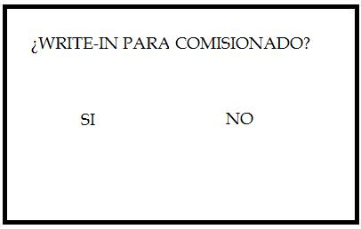
Write-in Option for the Commissioner
Figure 28

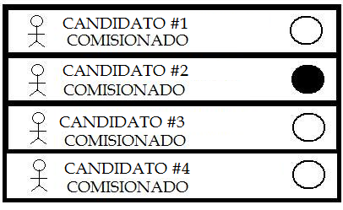
Commissioner Selection
Figure 29
When the voter has selected write in for one or both of the voting screens, the print out will include the corresponding area for a physical written nomination.

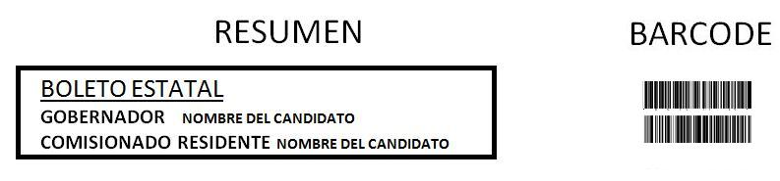
Print out copy
Figure 30

After the voting session, the voter will get a print out copy with a summary as seen above. If the voter chose to provide a write in, then the printed receipt will have a designated area to write down this information.

Software Design Considerations
The program design will not change in Sparrow. All features of the Raven software will be implemented in the 3 month period allotted for Sparrow with the exception of the implementation of the additional ballots and tallying software.

Hardware Design

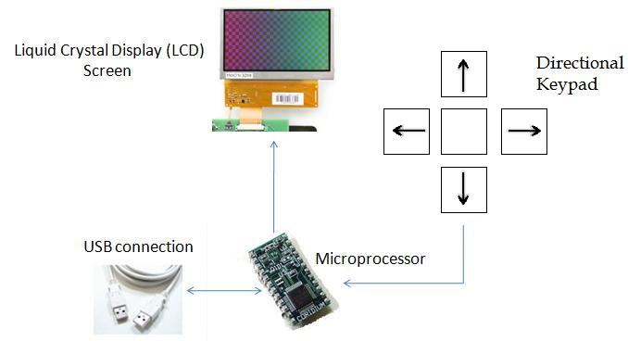
Sparrow Hardware Design Layout
Figure 31

The design initially was considering memory to store the images uploaded from the computer, but a design decision was made to make the interface and graphics all hardwired. The microprocessor will be sending to the LCD screen the corresponding pixel coordinates to create images to simulate the paper ballots. In this design, instead of a touch screen interface, we will be implementing a keypad that will navigate the ballots hardwired into the microprocessor. The keypad will consist of direction buttons and an ok button. Any regrets in voting can be remedied by navigating to a back button found in the LCD screen interface.

Future Work

Overview
The eVote system has been designed to provide a more secure and timely alternative to the current voting system. There are, however, some additional features that could add to the security of the system.

Fingerprint Scanning
Currently, most voters identify themselves with an identification card that has their picture, basic physical information for visual identification and other personal information. Additional fingerprint verification could be added to the system, and perhaps replace card identification in the future.
Fingerprint scanning would add several components to the system, including another database component to the system. All registered voters would have to scan their thumb fingerprints during registration time and this image would have to be stored in database. Later, prior to voting, the user would have to scan their thumb in order to gain access to the voting system. The system would use the fingerprint scan to verify that the voter has yet not voted during that Election Day.
In order to provide fingerprint verification, another software component needs to be added: Fingerprint Registration. This software could replace the existing registration software and provide an additional feature that would allow the capture of a fingerprint image. In order capture a fingerprint image, a fingerprint reader would need to be added to the system hardware. Depending on the fingerprint reader used, an SDK that would allow capturing information from the fingerprint reader would need to purchased or created.
Figure 47, depicts a possible User Interface for the registration software. This user interface is based on the current registration system. The new software, could replace the current image capture screen with a Fingerprint Capture screen.
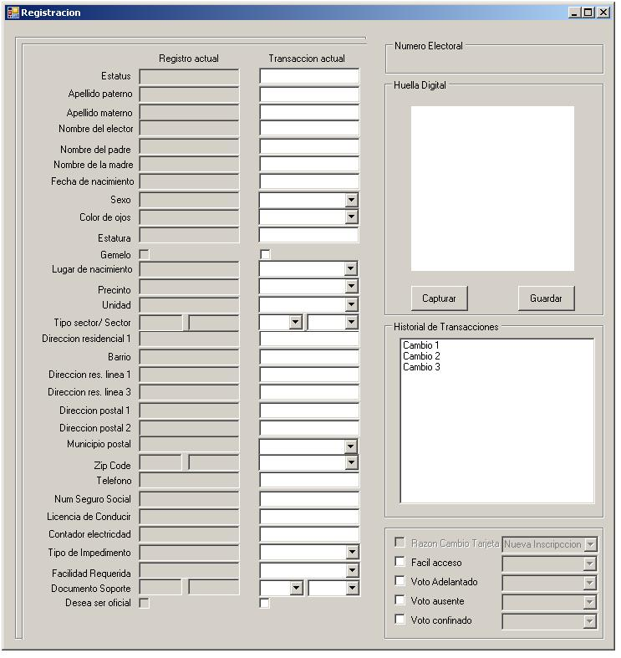
Voter Registration Software Interface
Figure 32

Accessible electronic voting
In order to provide equal access to new electronic voting systems, the system should be made completely accessible to voters with different impairments. For example, an audio feature could provide ballot information for the visually impaired and headphones could be provided for voter privacy. Finally, Kiosks and the eVote device will need to be planned in a way that allows the voting process to be unproblematic for voters that require wheel chairs or have some form of mobility impairment.

Glossary
- ROM - Read-Only Memory, a class of storage media used in computers and other electronic devices. This tells the computer how to load the operating system. [27]
- UART - Universal Asynchronous Receiver/Transmitter, a piece of computer hardware that translates data between parallel and serial forms. Is usually an individual (or part of an) integrated circuit used for serial communications over a computer or peripheral device serial port. UARTs are now commonly included in microcontrollers. [21]

Team

Javier Torres Santiago
Javier is a computer engineering student with concentration in software at the University of Puerto Rico, Mayaguez campus. His expected graduation date is December 2008. His software experiences include a material engineering student’s investigation software that studies the effects of hydrogen molecules in steel. Javier also has had a six month COOP experience as an IT (Information Technology) Test Engineer with Microsoft in Issaquah, Washington. Design a microprocessor simulator in C#. Programming in Java, C#, ASP .Net and basic HTML
Javier’s Hardware Experiences include the completion and soldering a functional radio in Electrical Analysis I at the University of Puerto Rico. Design a sixteen bit RISC microprocessor in the Computer Architecture and Organization course

Sylvia Rodríguez Rodríguez
Sylvia is a Computer Engineering student from the University of Puerto Rico at Mayaguez Campus. Her concentration is Software Engineering. She had worked with Java, C++ and Oracle 10G SQL. Sylvia has a six month Coop experience with IBM as a tester engineer. She also has a three month internship experience with Boeing Company as a Functional Analyst. She helps the team to change from the current development process to an agile process. As a functional analyst she performed gap analysis, requirements gathering and created functional specifications and design details documents.

Angel Vega Cortés
Angel Vega is a Computer Engineering student from the University of Puerto Rico at Mayagüez, specializing in computing systems. During this time he has worked with several programming languages, among these: Java, C/C++, and SQL. He has also done undergraduate research in Computer Systems Design and Architecture, and has recently culminated an internship with Johns Hopkins University Applied Physics Laboratory.

Laura Cruz Rodríguez
Laura Cruz is a Computer Engineering student with a concentration in Software Engineering at the University of Puerto Rico, Mayaguez. Her expected graduation date is December 2008. She has software design experience in the fields of databases design and web-based programming. In hardware design she has experience in the design of integrated analog circuits. Laura has work experience with companies like General Electric and Microsoft.

Team Training
The Team will need training in microprocessors and databases. Two of the four members have experience in databases, but no one has microprocessor experience. So the first month of project research will include microprocessor research. The research will provide knowledge on how microprocessors work and the components they possess. Also the training must include the methods of interfacing the microprocessor with computer software which is an essential part of the project due to the need for software to hardware communication.

References
[1] Zetter, Kim. "Aussies Do It Right: E-Voting." Wired Magazine. 3 Nov. 2003. 25 Aug. 2008 <http://www.wired.com/techbiz/media/news/2003/11/61045>.

[2] "Elecciones Generales 2004: Como Votar." Comisión Estatal de Elecciones de Puerto Rico. 25 Aug. 2008 <http://www.ceepur.org/sobrecee/leyelectoral/reglamentos/reglamentoeleccionesgenerales2004/comovotar/ index.htm>.

[3] "Government." Welcome to Puerto Rico! 25 Aug. 2008 <http://welcome.topuertorico.org/ government.shtml>.

[4] "Derechos del Elector." Comisión Estatal de Elecciones. 27 Aug. 2008 <http://www.ceepur.org/sobrecee/ presidencia/prensa/aviso/pdf/2007/ derechos%20elector%20rev.pdf>.

[5] Strickland, Jonathan, and Kevin Bonsor. "How E-voting Works." HowStuffWorks. 12 Mar. 2007. 25 Aug. 2008 <http://people.howstuffworks.com/e-voting.htm>.

[6] VONDERHEID, ERICA. "Standing Up For a Better E-Ballot Box." The Institute. 3 Sept. 2004. IEEE. 27 Aug. 2008 <http://www.ieee.org/portal/site/tionline/menuitem.130a3558587d56e8fb2275875bac26c8/ index.jsp?&pname=institute_level1_article&article=tionline/legacy/inst2004/sep04/9w.fballot.xml&>.

[7] Banuchi, Rebecca. "Sin marcha atrás las papeletas bilingües." El Nuevo Día. 6 Sept. 2008. 7 Sept. 2008 <http://www.elnuevodia.com/xstatic/endi/template/content.aspx?se=nota&id=453951>.

[8] ERNESTO RIVERA, MANUEL. "Judge orders English ballot printed in Puerto Rico." Yahoo! 27 Aug. 2008. 30 Aug. 2008 <http://news.yahoo.com/s/ap/20080828/ap_on_re_la_am_ca/ puerto_rico_bilingual_ballots_1>.

[9] "Voting Equipment Summary by Type as of 11-07-2006." Election Data Services. 29 Sept. 2006. Election Data Services. 27 Aug. 2008 <http://www.edssurvey.com/images/file/votingequipstudies%20/ ve2006_report.pdf>.

[10] "2006 Voting Equipment News Summary." Election Data Services. 2 Oct. 2006. Election Data Services. 27 Aug. 2008. <http://www.edssurvey.com/images/file/votingequipstudies%20/ve2006_news.pdf>

[11] "2006 Voting Equipment Study." Election Data Services. 2 Oct. 2006. Election Data Services. 27 Aug. 2008 <http://www.edssurvey.com/images/file/votingequipstudies%20/ve2006_news.pdf>.
[12] "November 2006 Voting Equipment Usage by County." Election Data Services. 29 Sept. 2006. Election Data Services. 27 Aug. 2008 <http://www.edssurvey.com/images/file/votingequipstudies%20/ ve2006_map.pdf>.

[13] "The Voting Rights Act of 1965." Civil Rights Division - Voting Section. United States Department of Justice. 27 Aug. 2008 <http://www.usdoj.gov/crt/voting/intro/intro_b.htm>.

[14] "IVotronic." ES&S. ES&S. 25 Aug. 2008 <http://www.essvote.com/html/products/ivotronic.html>.

[15] "AVC ADVANTAGE." Sequoia Voting Systems. Sequoia Voting Systems. 25 Aug. 2008 <http://www.sequoiavote.com/advantage.html>.

[16] "ELECTronic 1242 Voting System." Guarding Voting Systems. Danaher Corporation. 25 Aug. 2008 <http://guardianvoting.com/gvs/vs.html>.

[17] "EVACS." Software Improvements. Software Improvements. 25 Aug. 2008 <http://www.softimp.com.au/evacs/products.html>.

[18] "Features." Elecciones en Puerto Rico. <http://www.electionspuertorico.org/>.
[19] Devisser, Bruce. "Designing Touch LCDs for Portable Devices." Fujitsu. July 2003. <http://www.fujitsu.com/us/ news/inthenews/fcai_20030701.html>.
[20] "LCD-08335." Sparkfun Electronics. <http://www.sparkfun.com/commerce/ product_info.php?products_id=8335>.
[21] "Universal asynchronous receiver/transmitter." Wikipedia. <http://en.wikipedia.org/wiki/uart>.
[22] "DEV-00476." Sparkfun Electronics. <http://www.sparkfun.com/commerce/ product_info.php?products_id=476>.
[23] "DEV-08284." Sparkfun Electronics. <http://www.sparkfun.com/commerce/ product_info.php?products_id=8284>.
[24] "Megavision MV155UB." Amazon.com. <http://www.amazon.com/megavision-mv155ub-touchscreen-lcd-monitor/dp/b0016bcvxg/ref=pd_bbs_1?ie=utf8&s=electronics&qid=1220552682&sr=8-1>.
[25] "Standard Windows Keyboard Layout - Windows Natural Keyboard." SEO Consultants. 12 July 2008. <http://www.seoconsultants.com/windows/keyboard/>.
[26] "Thank goodness it's Friday." Sparkfun Electronics. 22 Aug. 2008. <http://www.sparkfun.com/ commerce/categories.php>.
[27] "Rom." Wikipedia. <http://en.wikipedia.org/wiki/rom>.
[28] Hacking Democracy. Dir. Simon Ardizzone & Russell Michaels. HBO Documentary Films. 2006.
[29] "The Uniformed and Overseas Citizens Absentee Voting Act." Civil Rights Division - Voting Section. United States Department of Justice. 27 Aug. 2008 <http://www.usdoj.gov/crt/voting/misc/activ_uoc.htm>.
[30] "Voter Confidence and Increased Accessibility Act of 2003." The Library of Congress. The Library of Congress. 27 Aug. 2008 <http://thomas.loc.gov/cgi-bin/query/z?c108:h.r.2239:>.
[31] "The Help America Vote Act of 2002." U.S. Department of Justice. Civil Rights Division - Voting Section. 27 Aug. 2008 <http://www.usdoj.gov/crt/voting/hava/hava.html>."Las Papeletas con Tres Cruces en las Elecciones Generales de 2004." Elecciones en Puerto Rico. <http://electionspuertorico.org/referencia/tres.cruces.html>.

Layton, Julia. "How can someone tamper with an electronic voting machine?" HowStuffWorks. 22 Sept. 2006. 25 Aug. 2008 <http://people.howstuffworks.com/vote-tampering.htm>.

"MSP-FET430 User's Guide." Texas Instruments. May 2008. Texas Instruments. <http://focus.ti.com/lit/ ug/slau157g/slau157g.pdf>.
"MSP430 Product Review." Texas Instruments. June 2008. Texas Instruments. <http://focus.ti.com/ lit/ds/symlink/msp430f5418.pdf>.
"MSP430F149." Texas Instruments. Texas Instruments. <http://focus.ti.com/docs/prod/folders/ print/msp430f149.html>.
Longstreet, David H. “Function Point Training and Analysis Manual.” Software Metrics. 2001. <http://softwaremetrics.com/Function%20Point%20Training%20Booklet%20New.pdf>
"Barcode". <http://en.wikipedia.org/wiki/Barcode>.
"Barcode Comparison". <http://www.makebarcode.com/>.
"Barcode Fonts". <http://www.bizfonts.com/>.
"Code 39 Specification". <http://www.barcodeman.com/info/c39_1.php3>.
"Code 128 Bar Code Software & Fonts". < http://www.code128barcodes.com/>.
"How a Bar Code Reader Works". <http://www.taltech.com/TALtech_web/resources/intro_to_bc/ bcpwork.htm>.
"Which Bar Code Scanner Interface is right for me?". <http://www.taltech.com/products/interface.htm>
"Barcode Macros for Office". <http://www.dlsoft.com/products/barcode_macros.htm>.
"ID Tech EconoScan Scanners". <http://www.barcodediscount.com/catalog/idtech/econoscan.htm>.
"IDAutomation Plug 'n Play USB Barcode Scanner" <http://www.idautomation.com/scanners/ SC5USB.html>.
"Laser Scanning or Digital Imaging: Which Bar Code Scanning Technology Is Right for Your Application?". <http://www.motorola.com/staticfiles/Business/Products/Bar%20Code%20Scanning/Bar%20Code%20Scanners/Fixed%20Mount%20Scanners/MiniScan%2012xx/_Documents/Static%20Files/Laser_Scan_Digital_Image_WP_New.pdf>.
"Bar Code Scanners". <http://www.elfring.com/scanner.htm>.
"Barcode Scanner". <http://www.posmicro.com/>.
"Comparison of Barcode Printers". <http://www.barcoding.com/information/barcode-printer-comparison.shtml.>.
"Job Salaries". < http://salary.com/>.
Vega Riveros, J. Fernando. "Preparing a Budget for a Project". Course notes. Design Project in Computer Engineering. Department of Electrical and Computer Engineering. University of Puerto Rico, Mayaguez Campus. August 15,2008.
"Software Design". < http://en.wikipedia.org/wiki/Software_design>.
"Design Pattern". < http://en.wikipedia.org/wiki/Design_pattern_(computer_science)>.
"Chain of Responsibility Pattern". < http://en.wikipedia.org/wiki/Chain_of_responsibility_pattern>.
McConnell, Steve. Code Complete, Second Edition. Redmond, Washington: Microsoft Press, 2004.
Pressman, Roger. Software Engineering: A practitioner's Approach. New York: McGraw-Hill, 2001.

Appendix

Gantt Chart


